1.PRINT SPACES

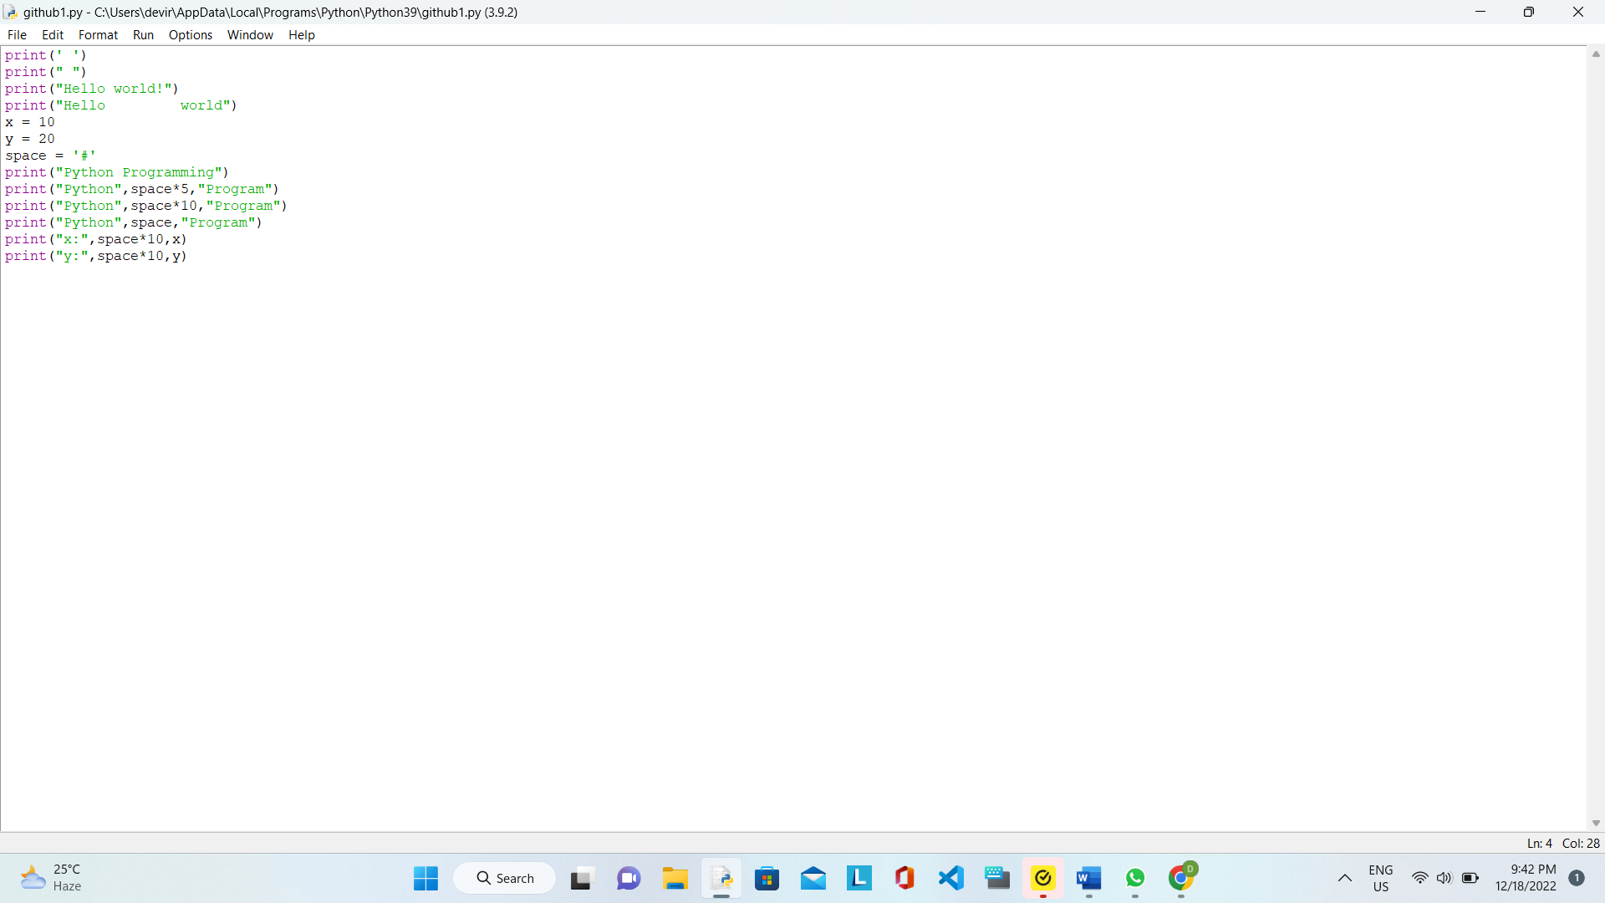

OUTPUT:

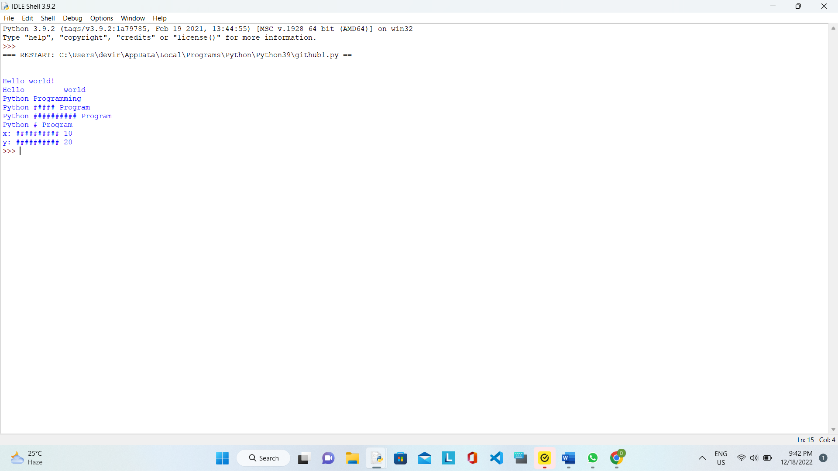

2.PRINT VARIATIONS

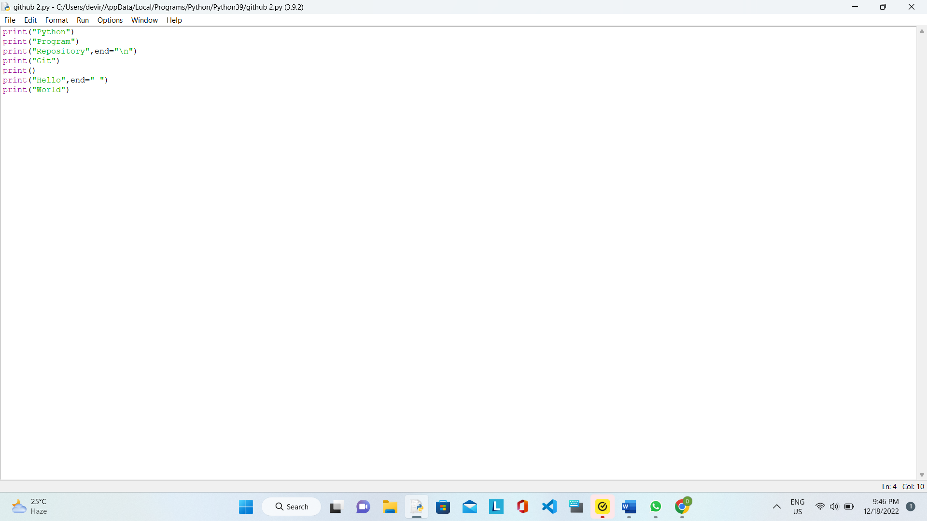

OUTPUT:

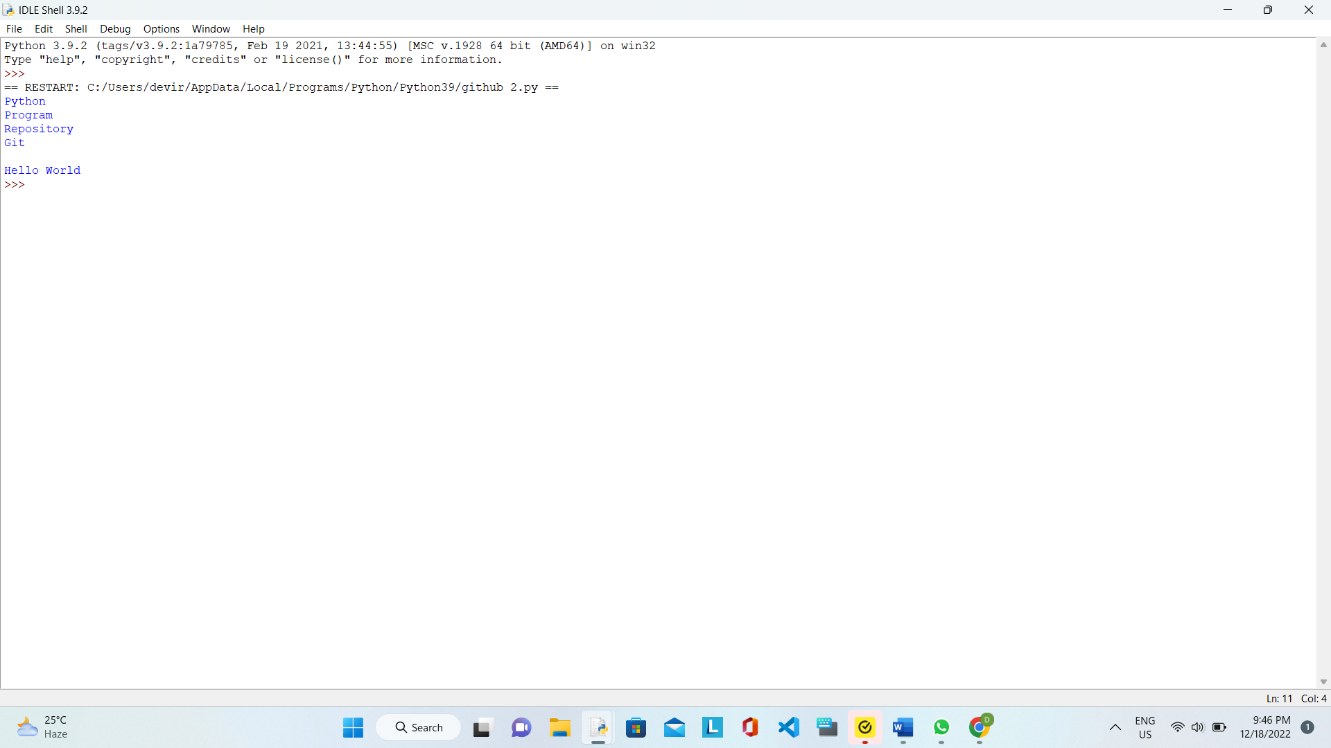

3.PRINT TEXT USING USER DEFINED FUNCTION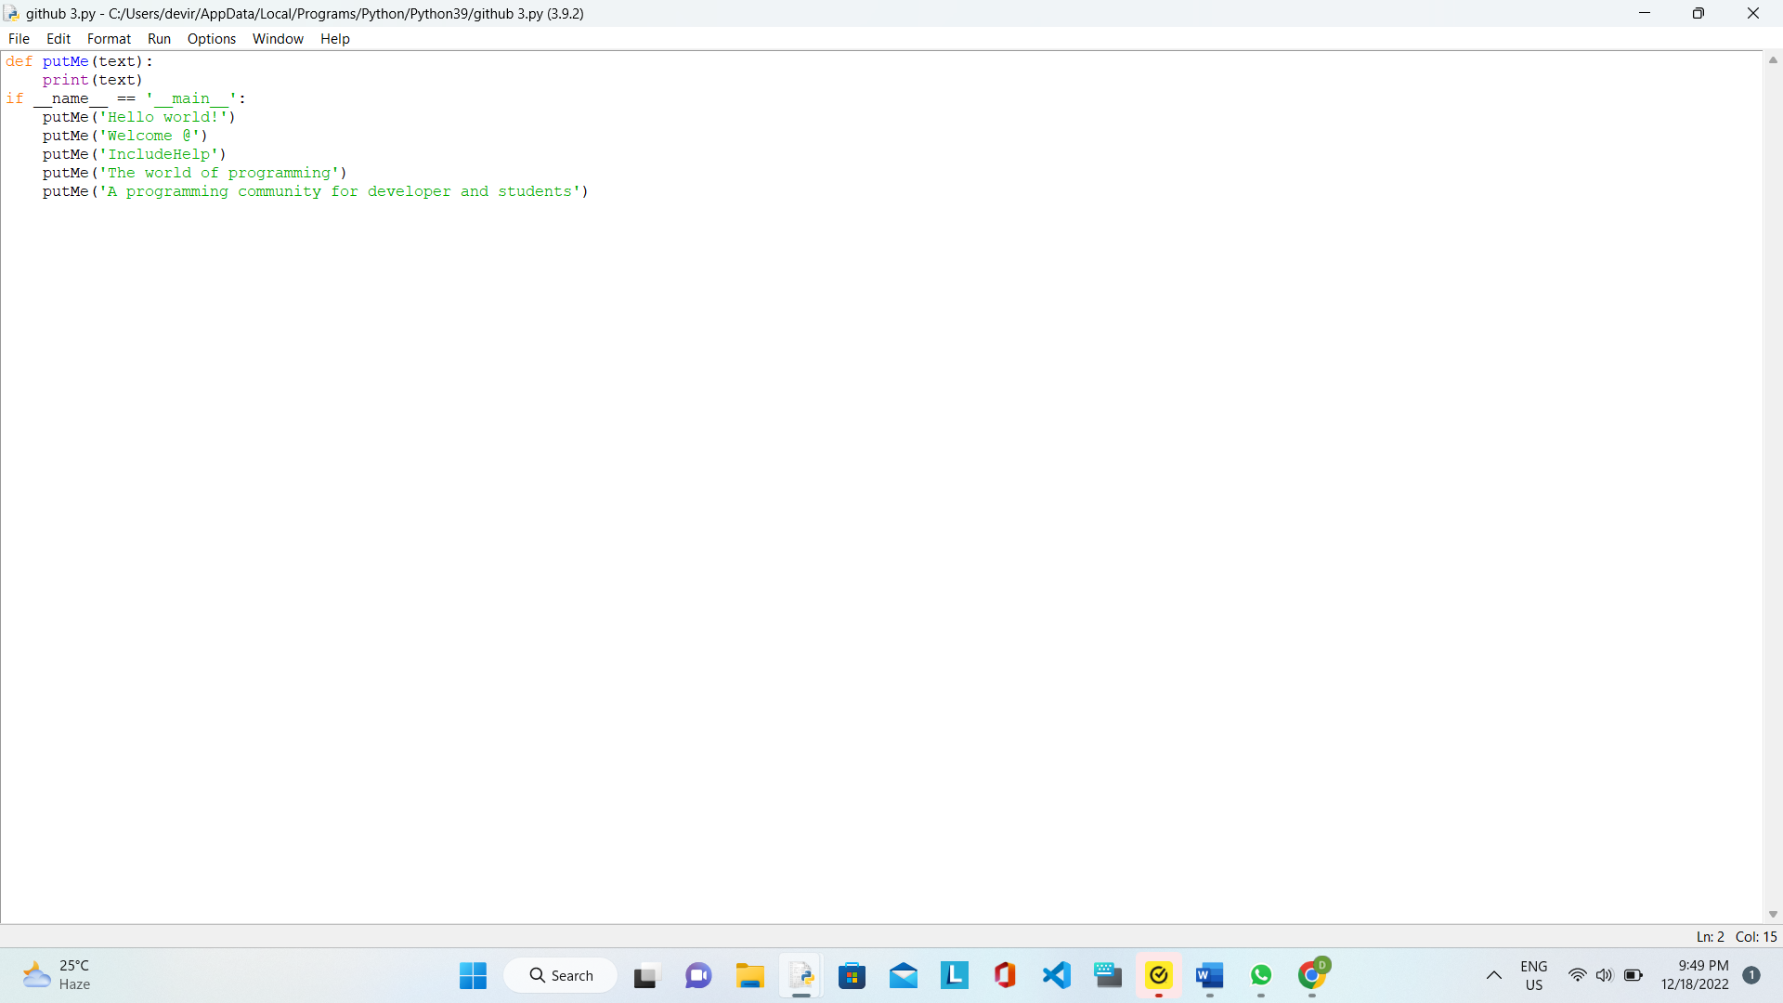

OUTPUT:

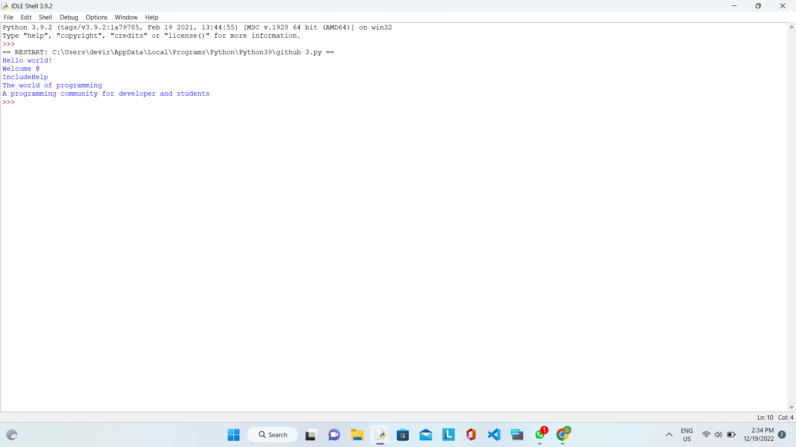

4. PRINT DIFFERENT VALUES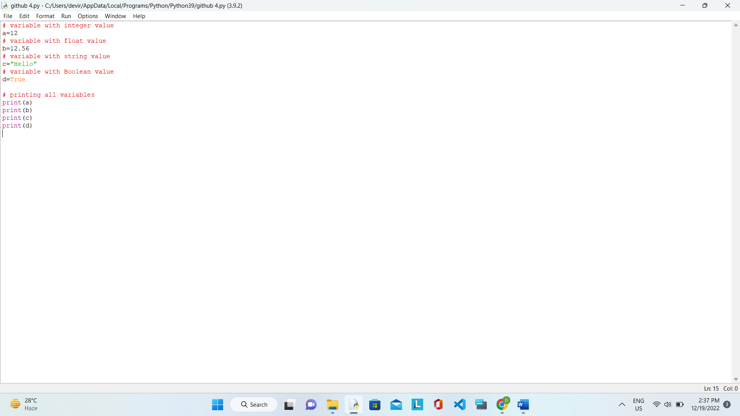

OUTPUT:

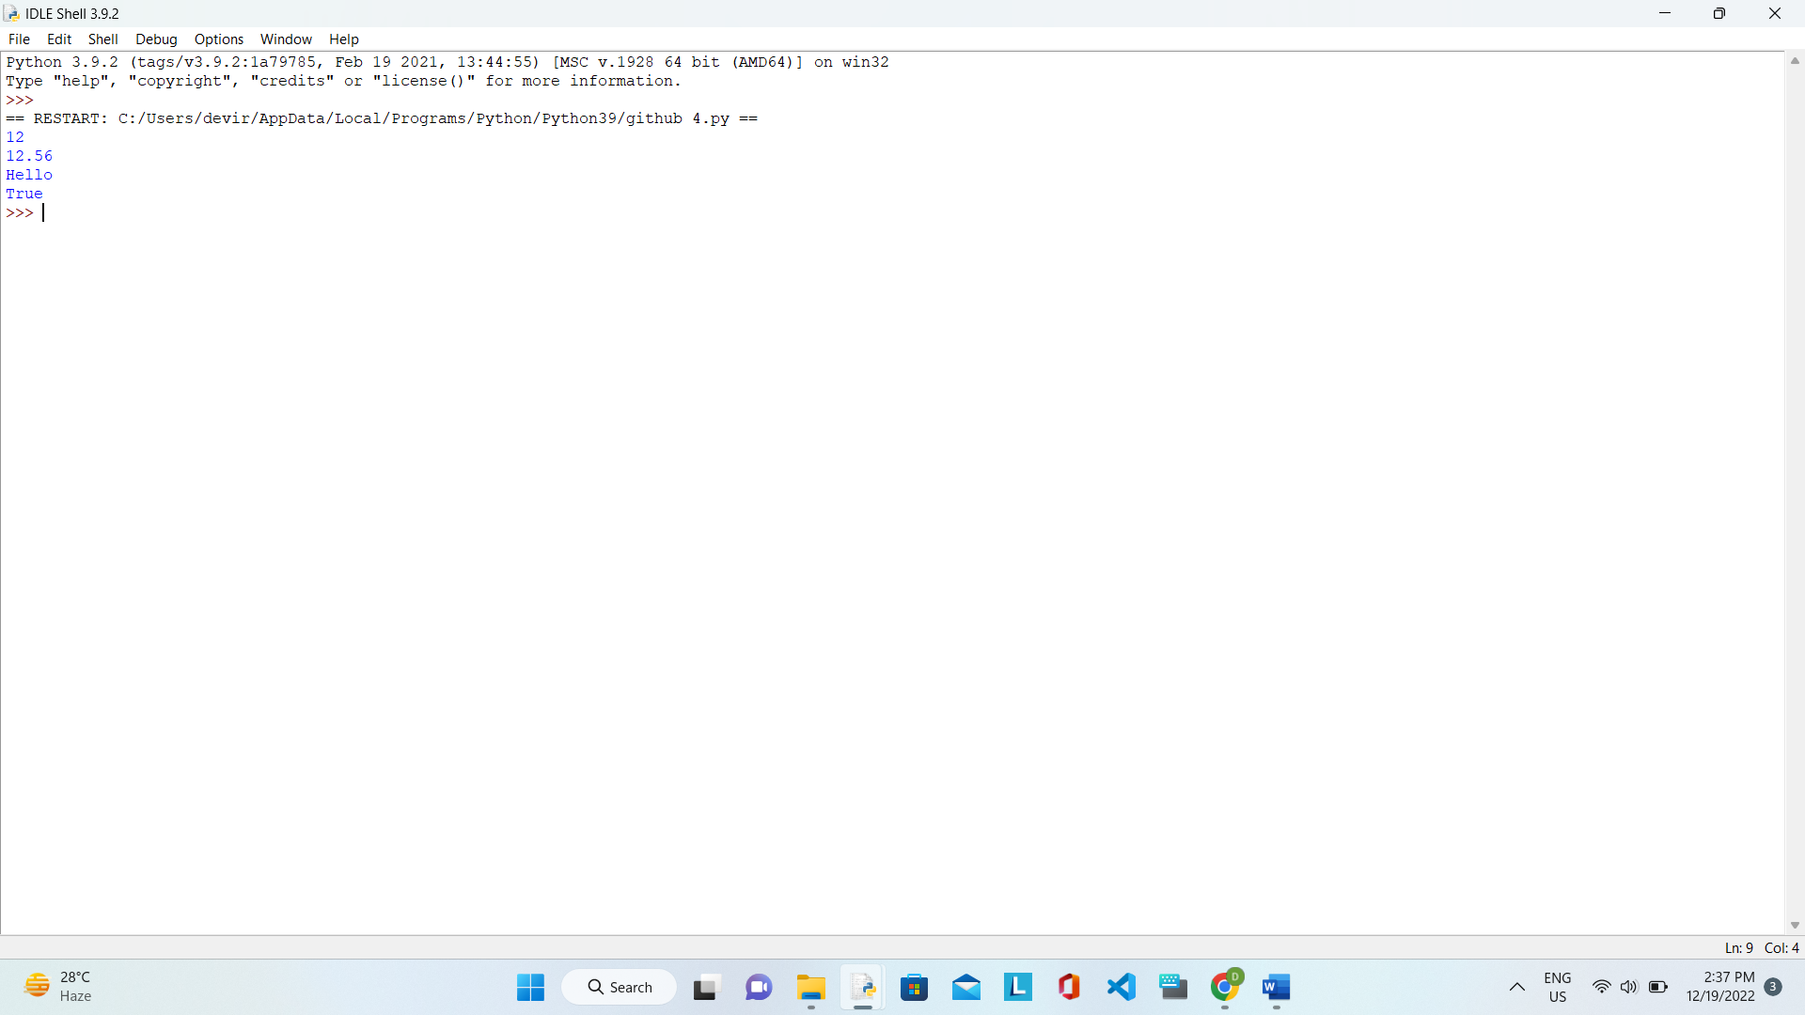

5. Declare different types of variables, print their values, types and Ids:

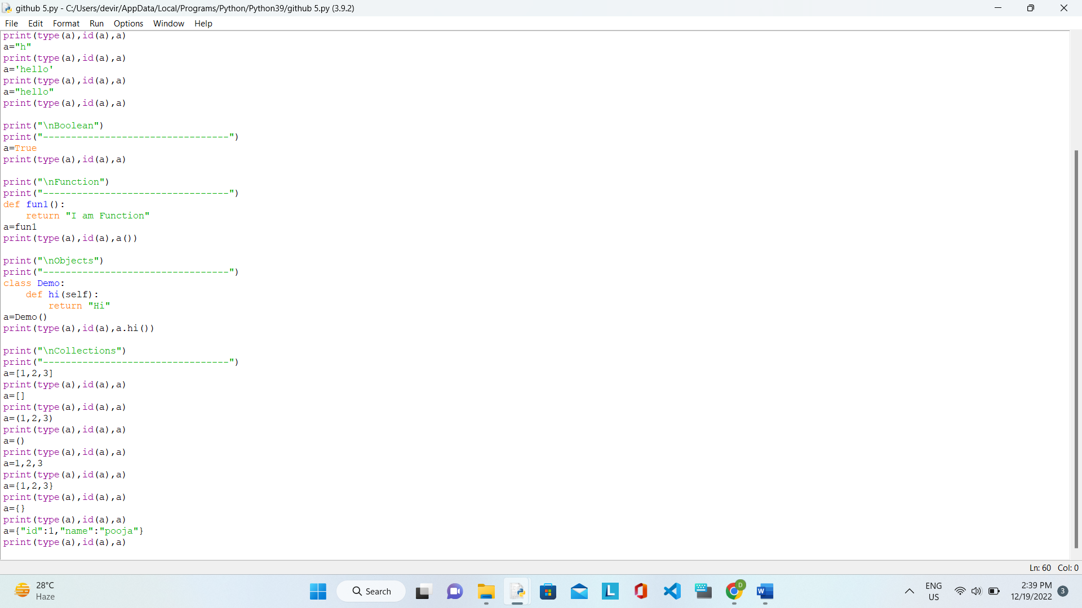

OUTPUT:

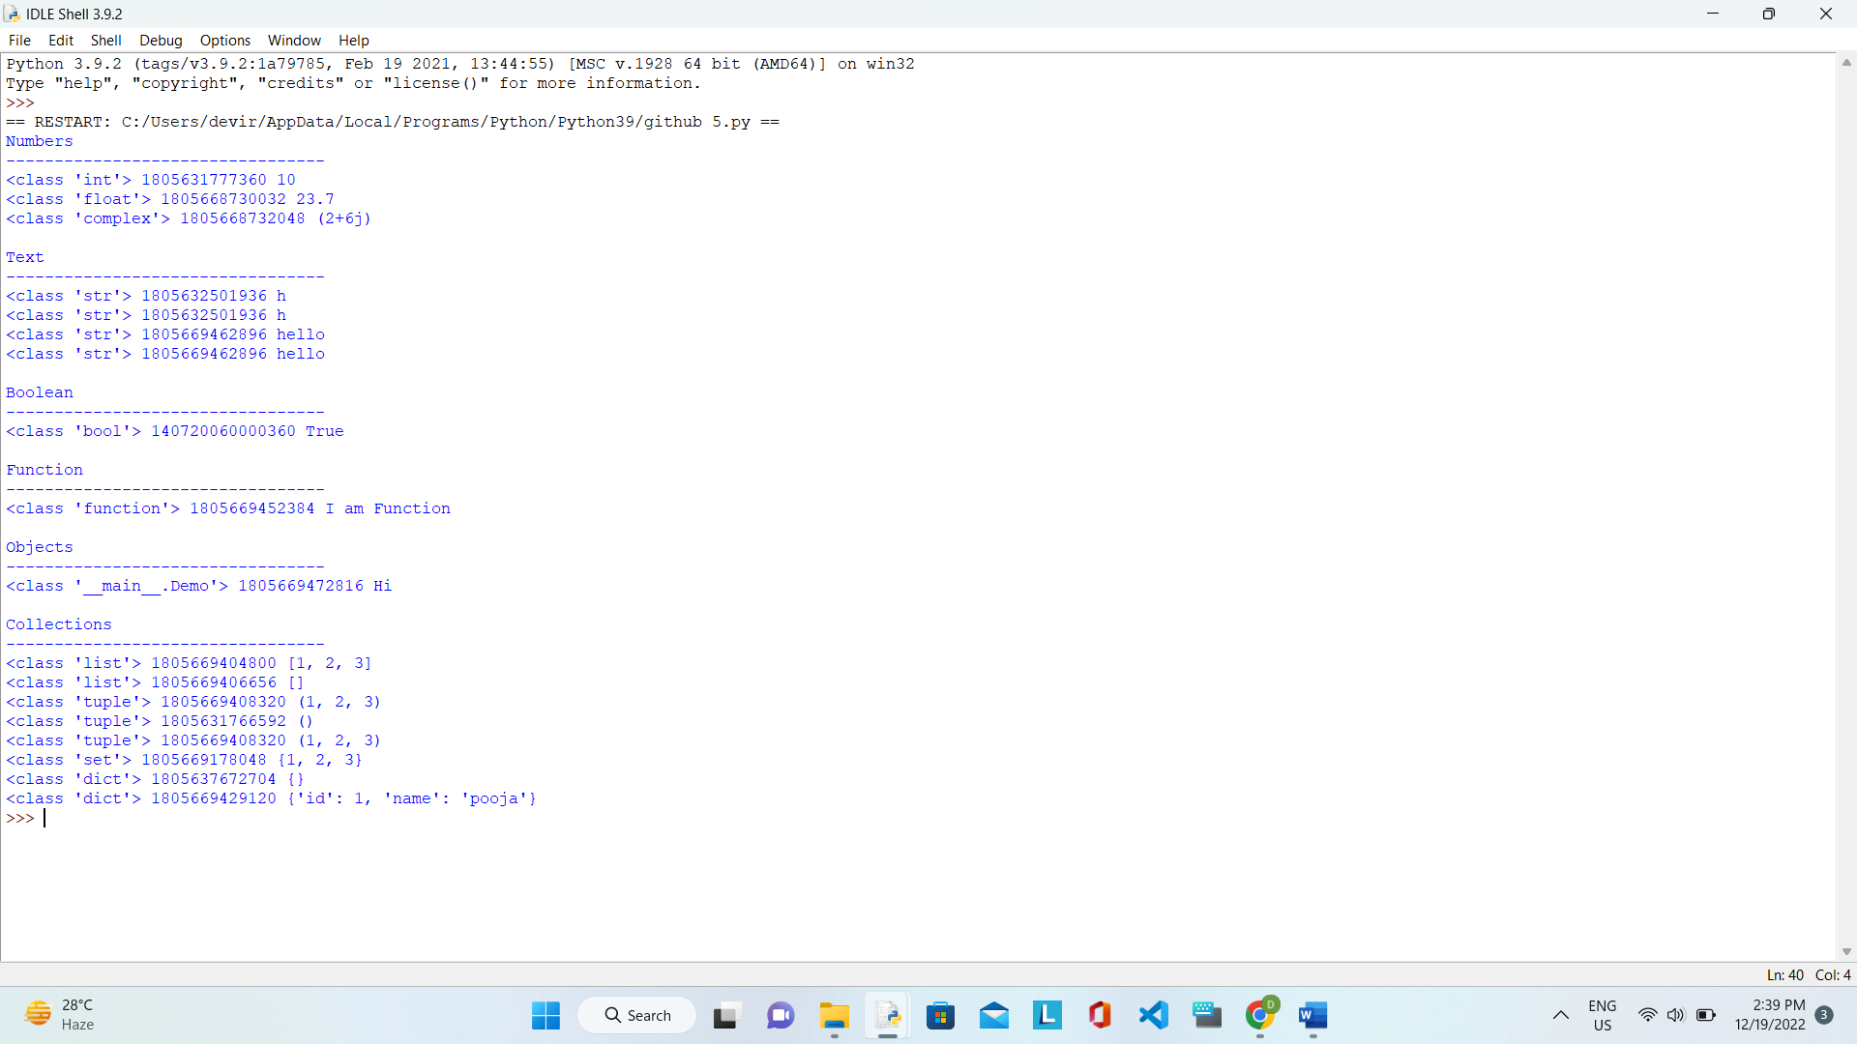

6. DEMONSTRATE VARIABLE TYPE: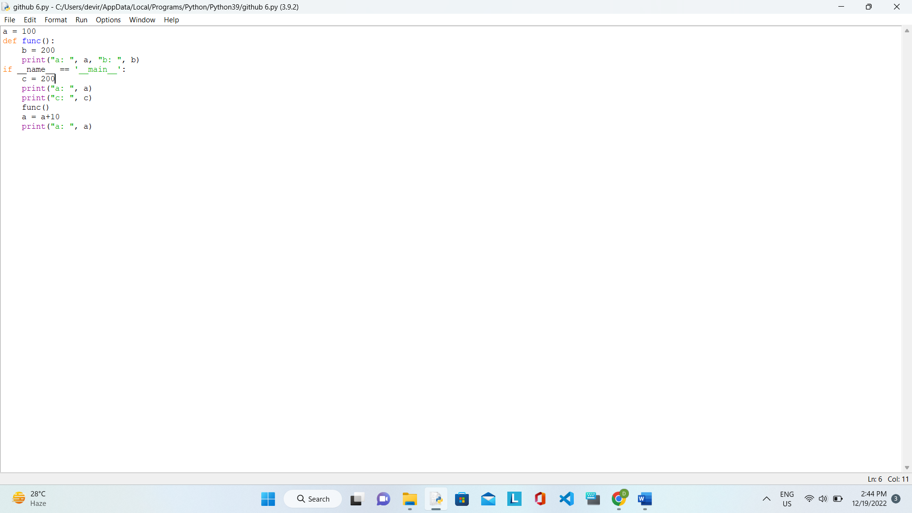

OUTPUT:

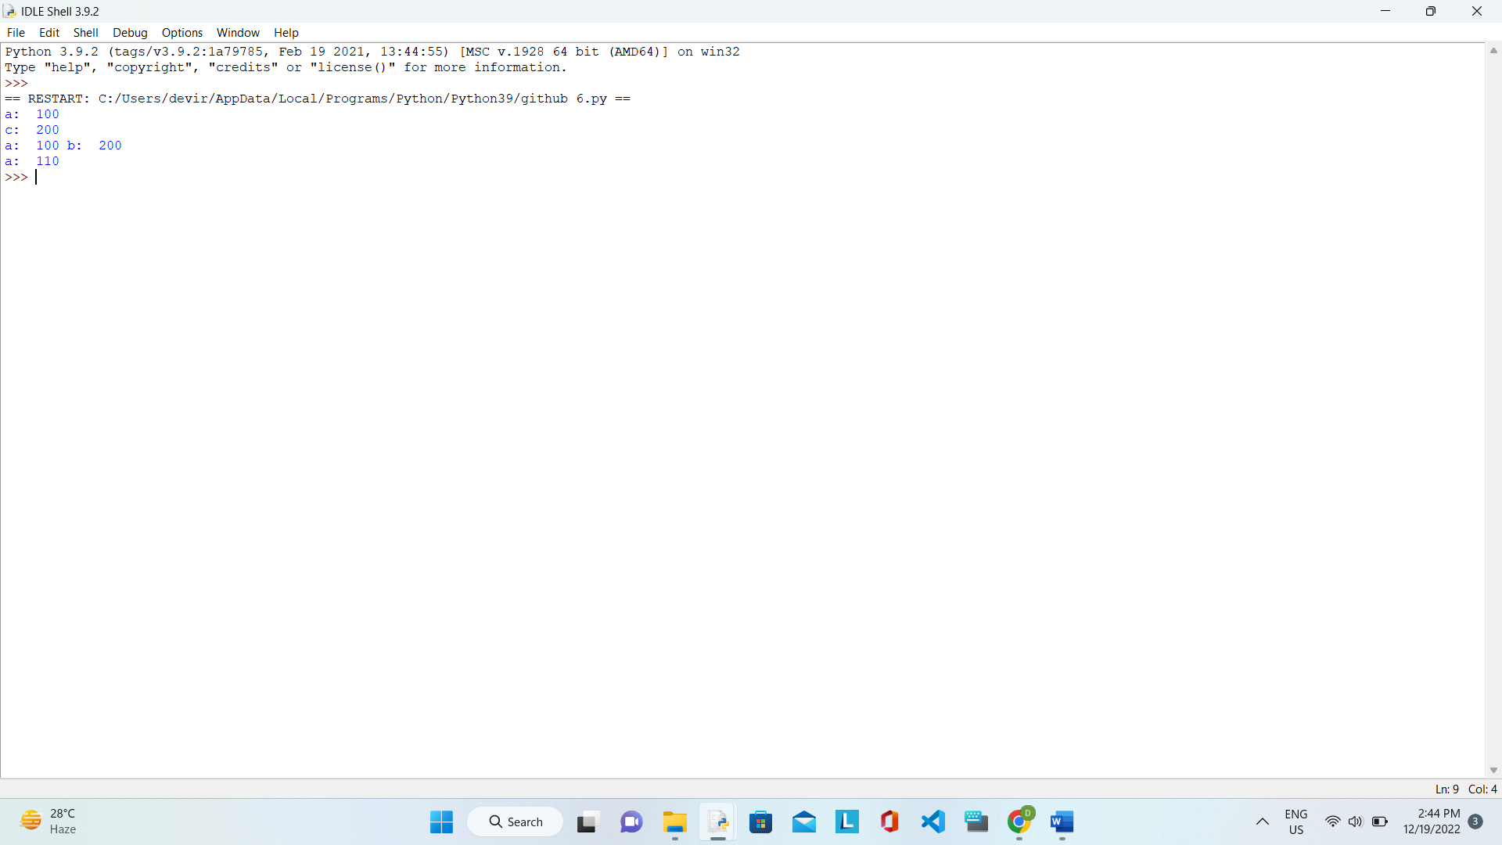

7. DETERMINE TYPE OF AN OBJECT: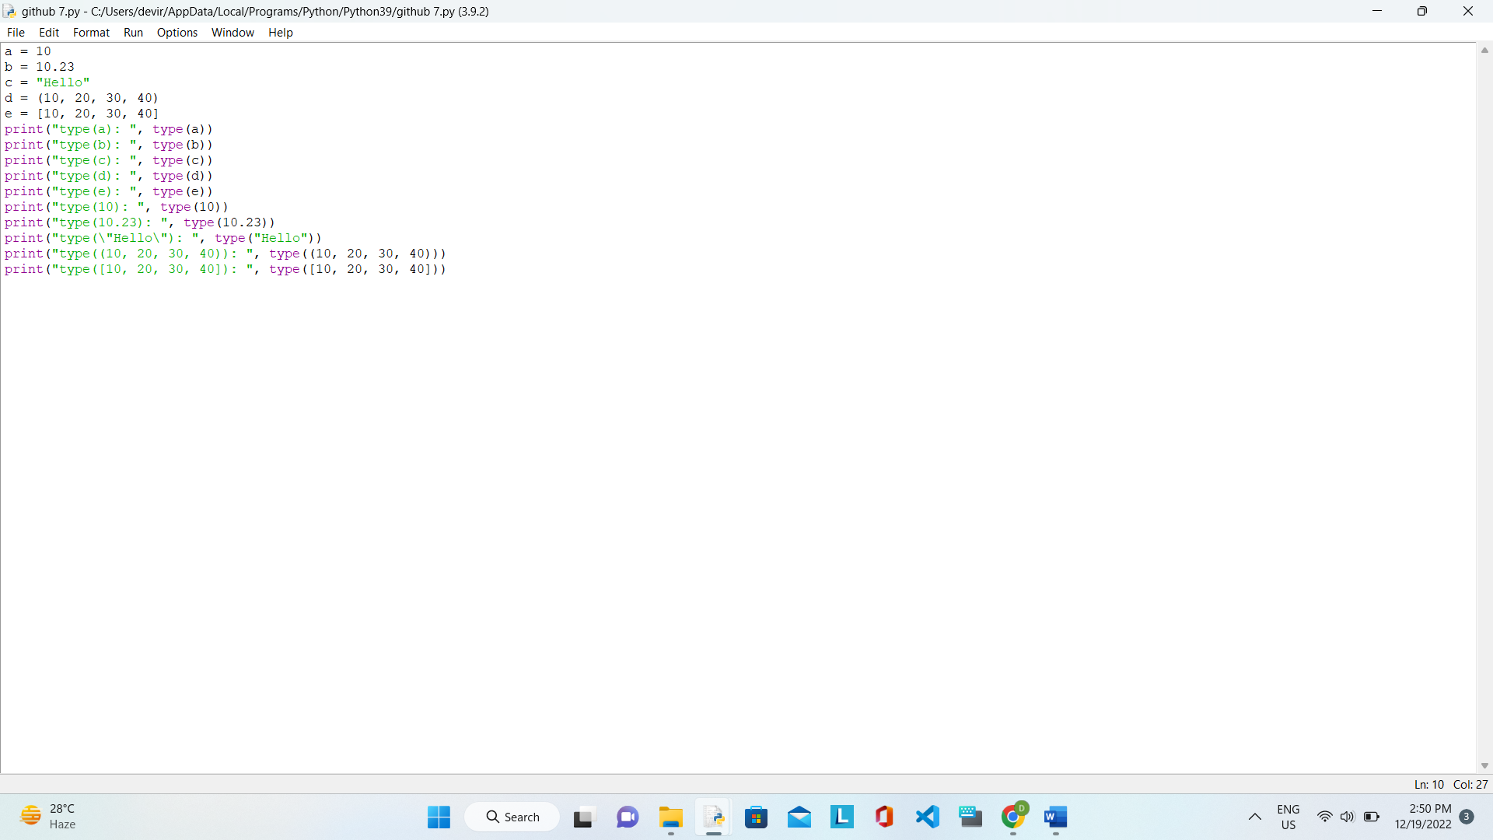

OUTPUT:

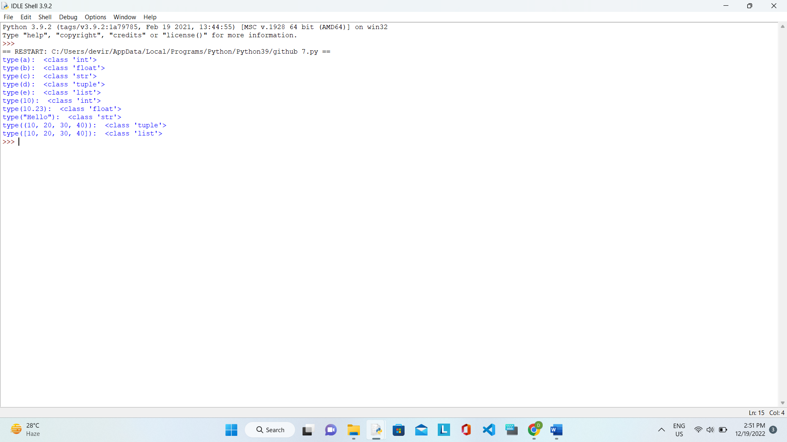

8. CREATE NUMBER VARIABLES: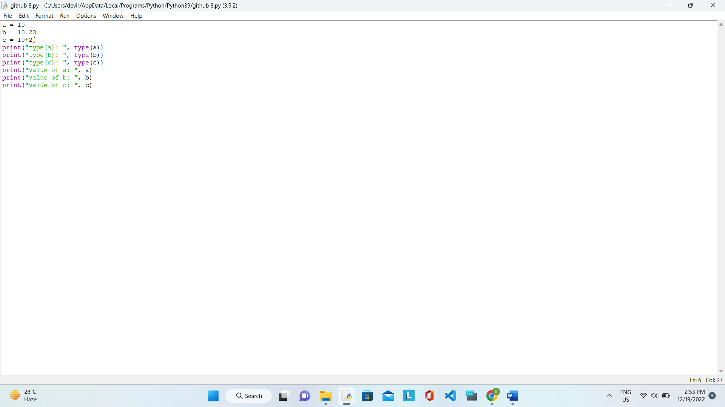

OUTPUT:

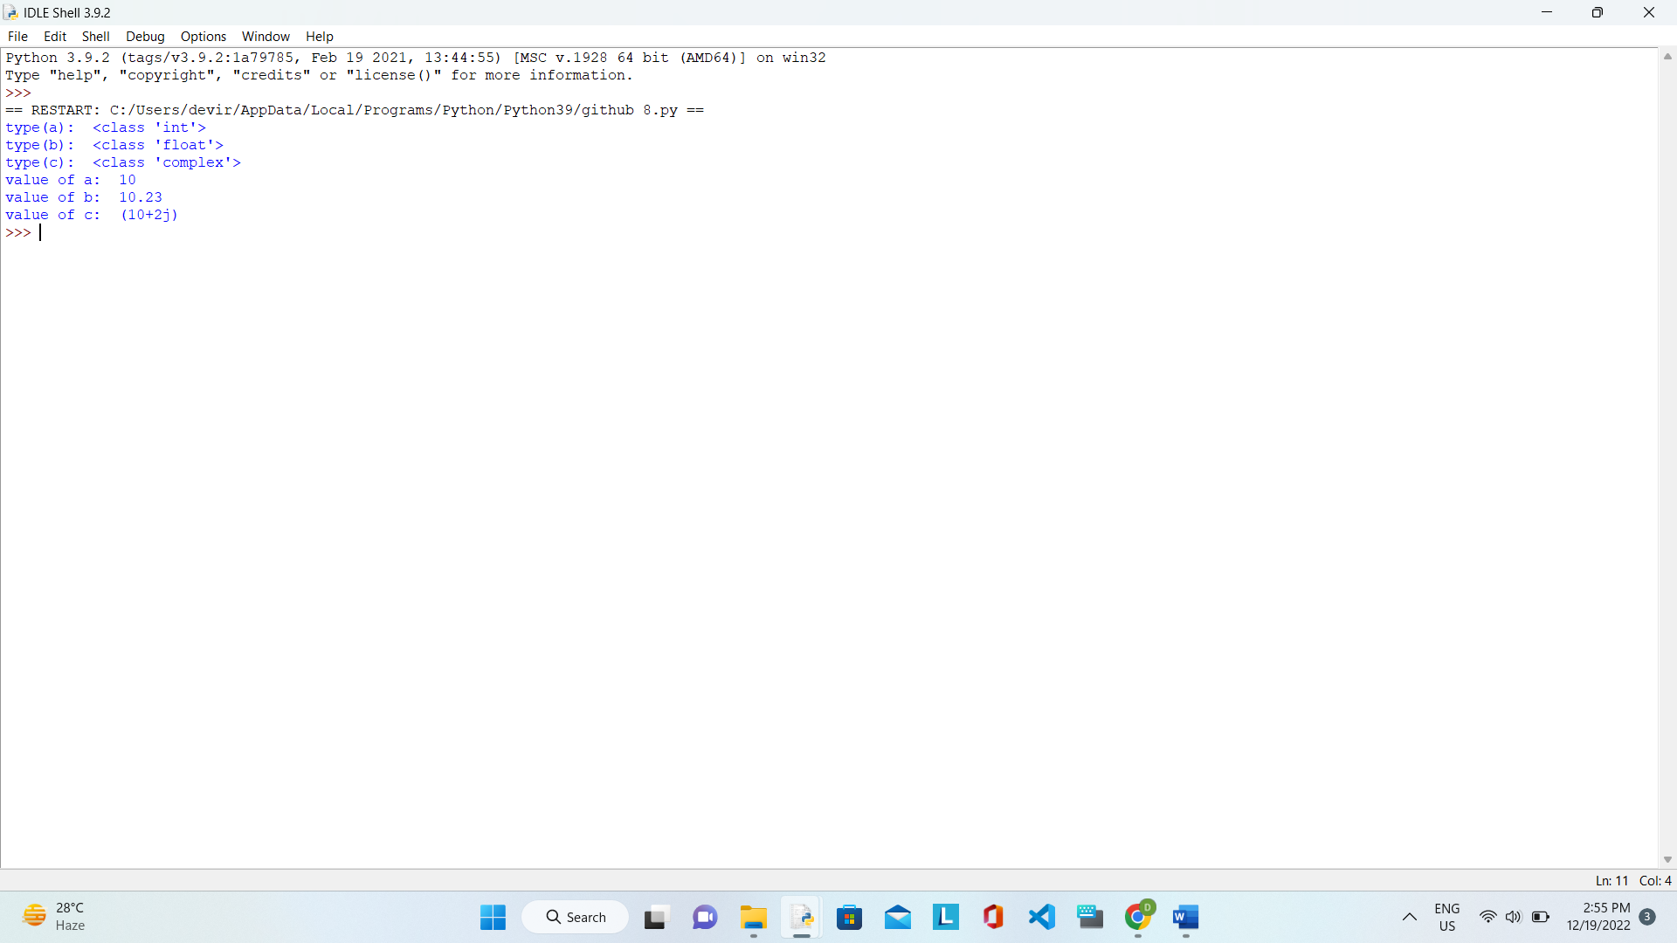

9.CREATE INT VARIABLE BY ASSIGNING BINARY VALUE:

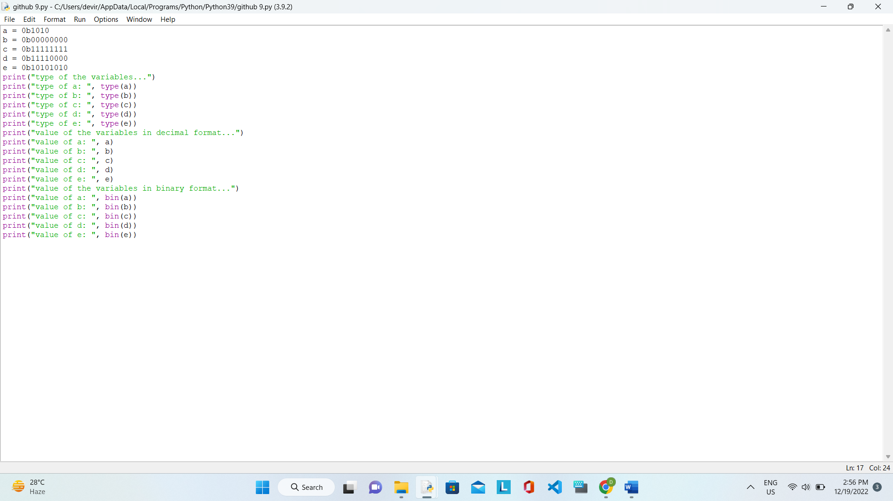

OUTPUT:

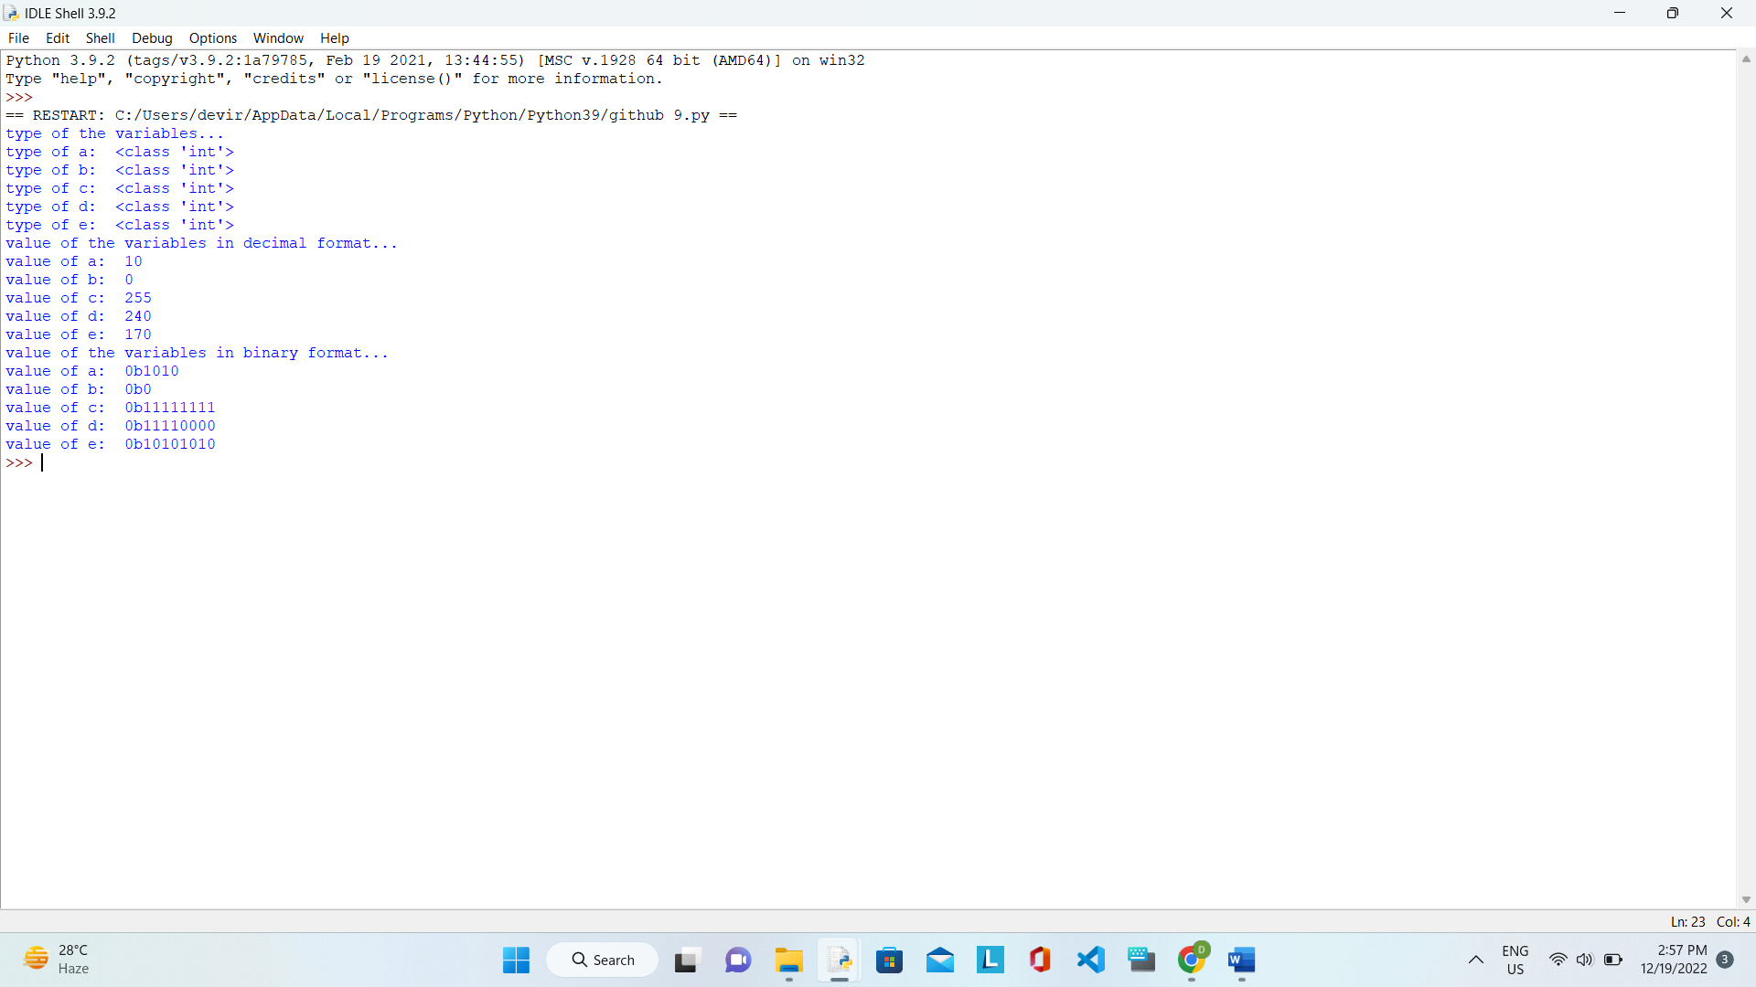

10. CREATE INT VARIABLE BY ASSIGNING OCTAL VALUE:

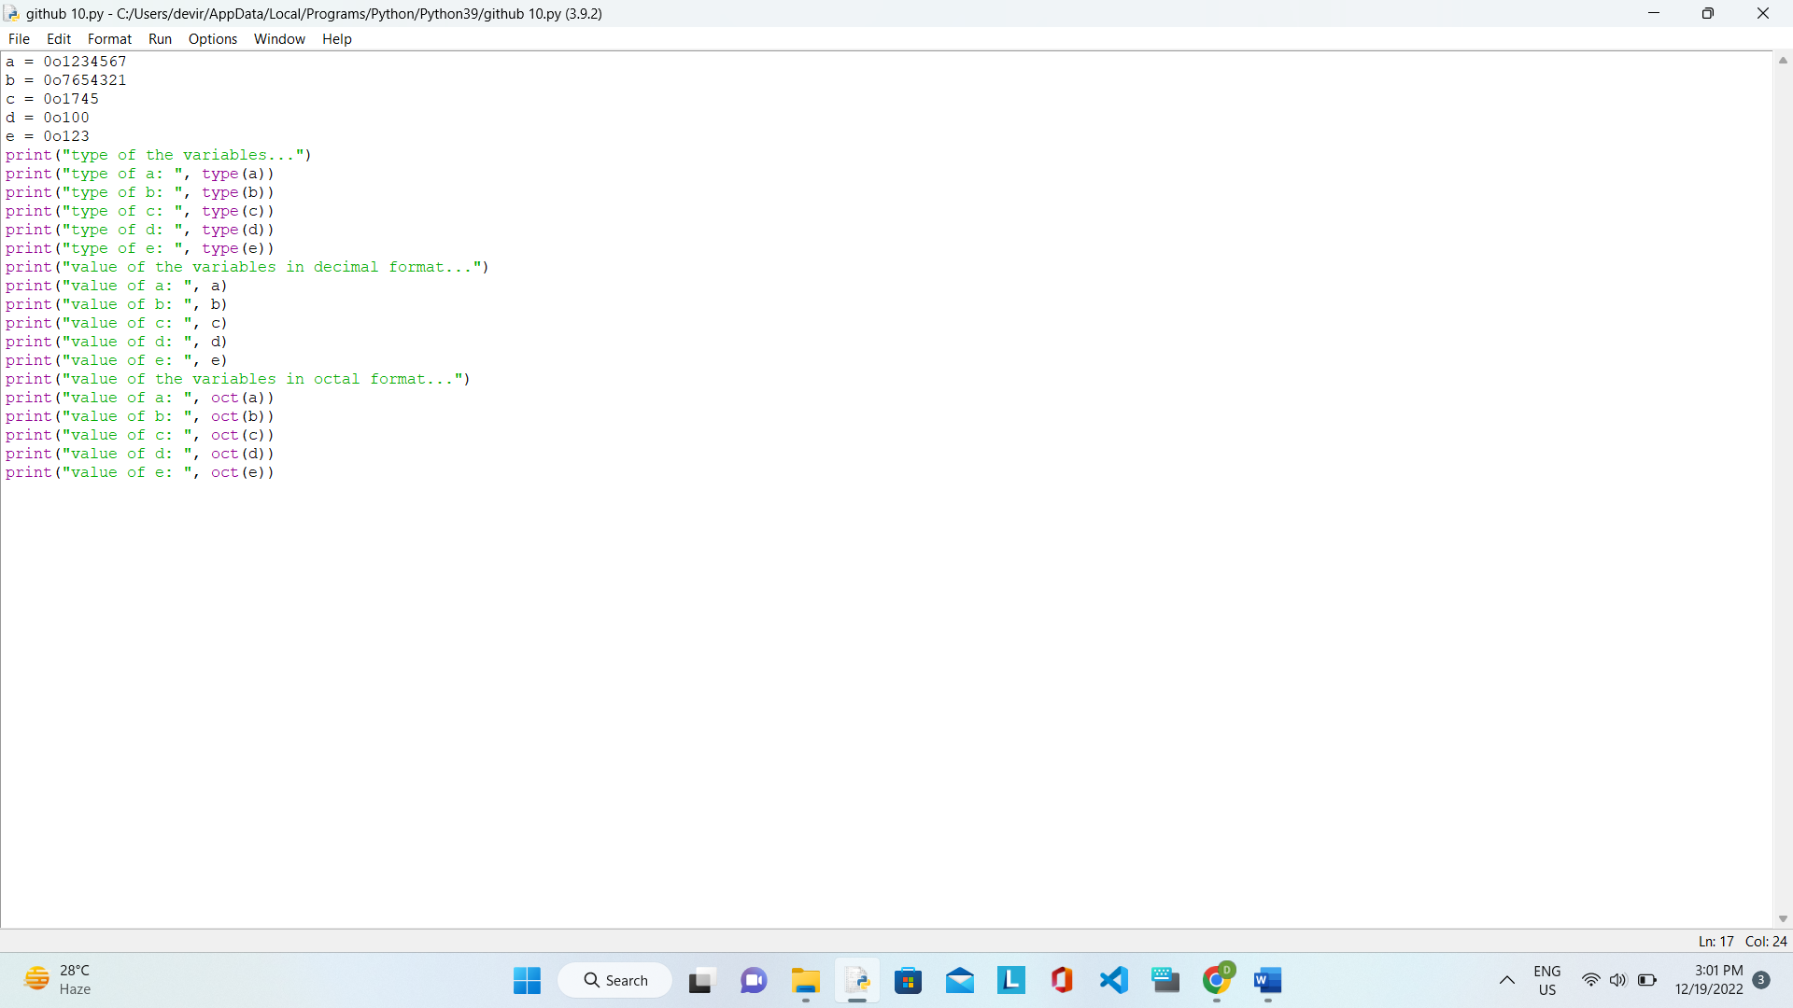

OUTPUT:

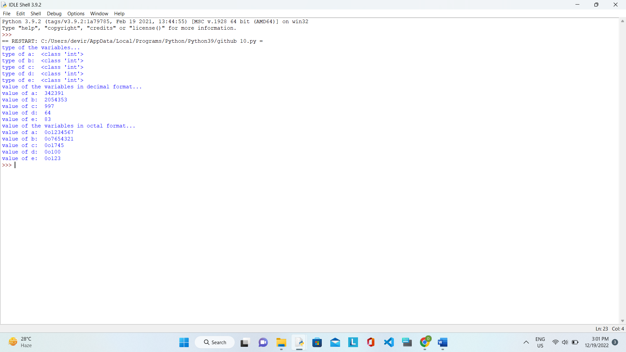

11. CREATE INT VARIABLE BY ASSIGNING HEXADECIMAL VALUE:

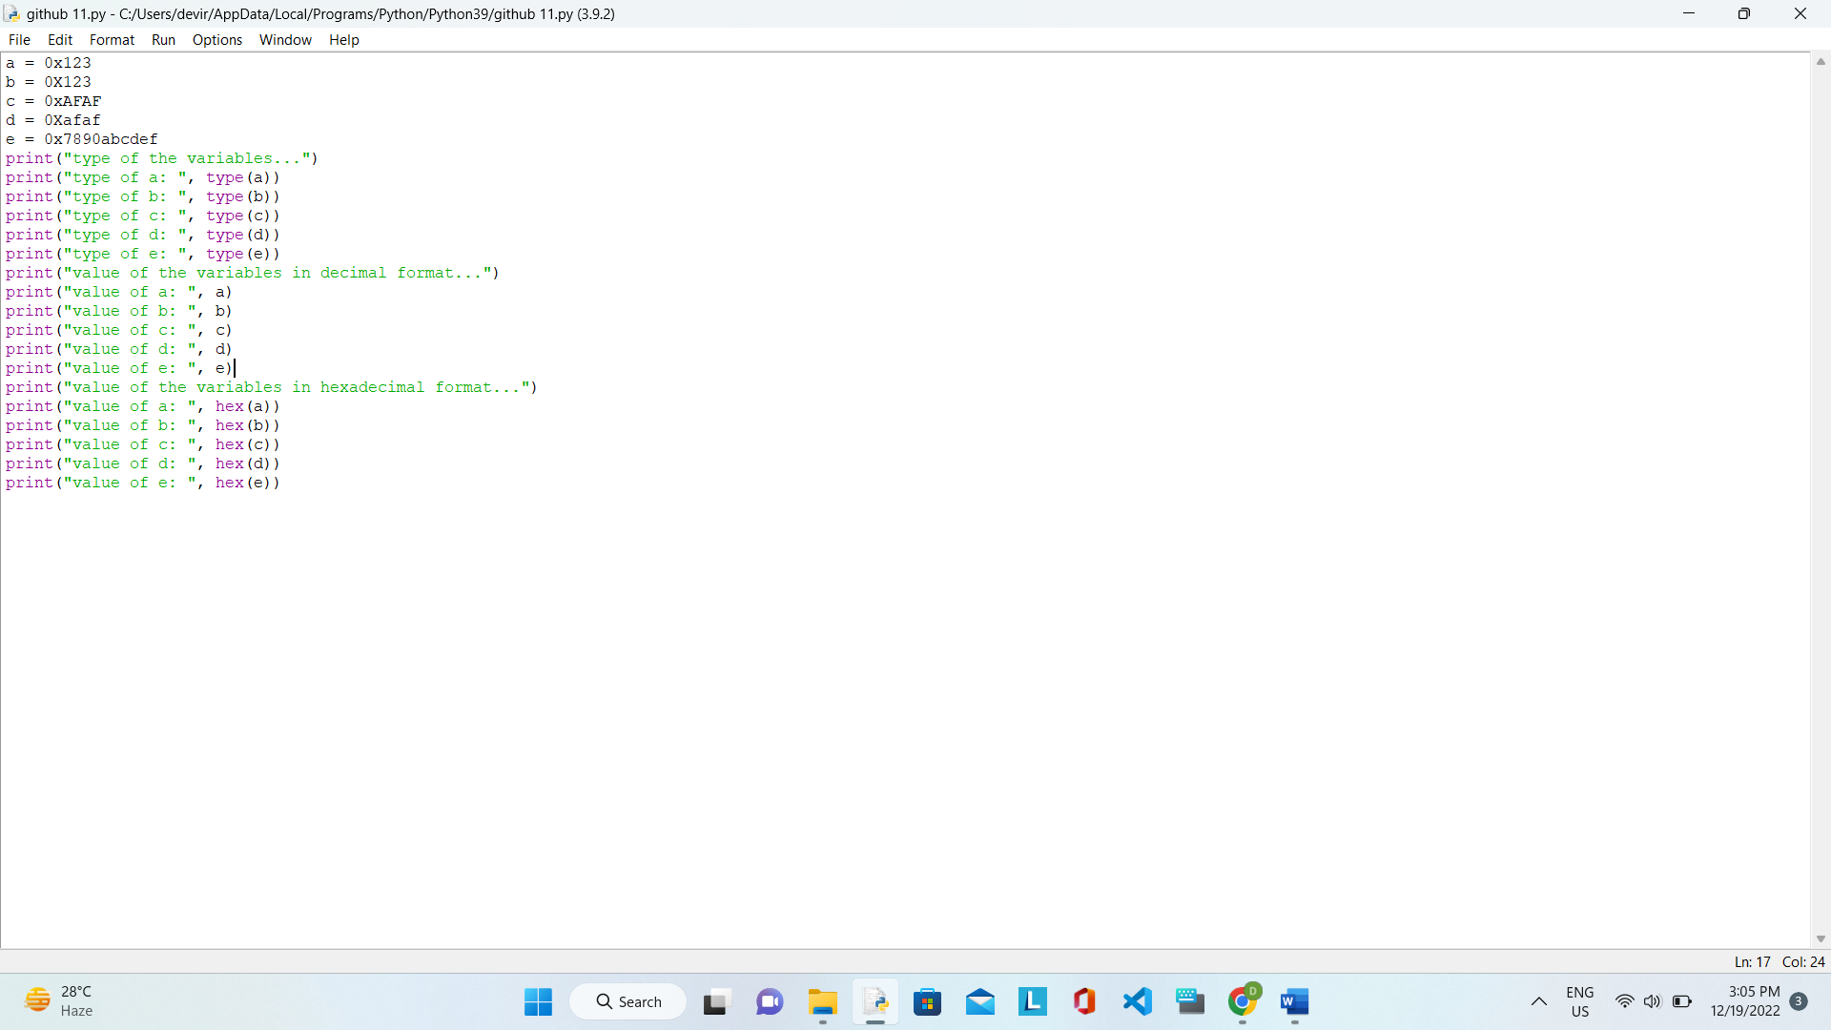

OUTPUT:

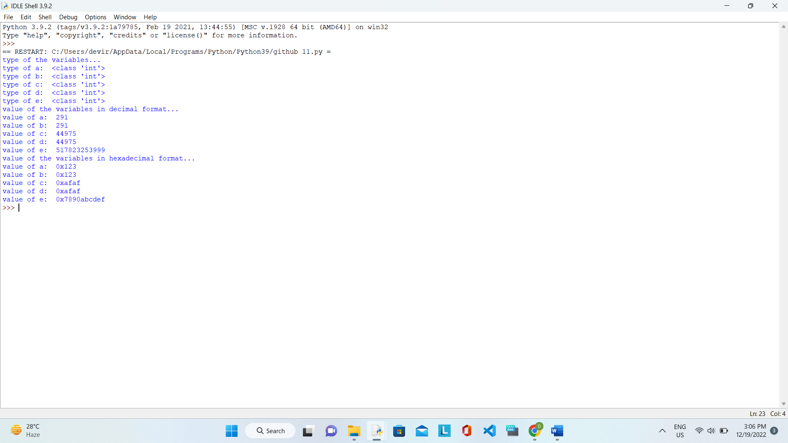

12. TYPECASTING INT INTO INTEGER: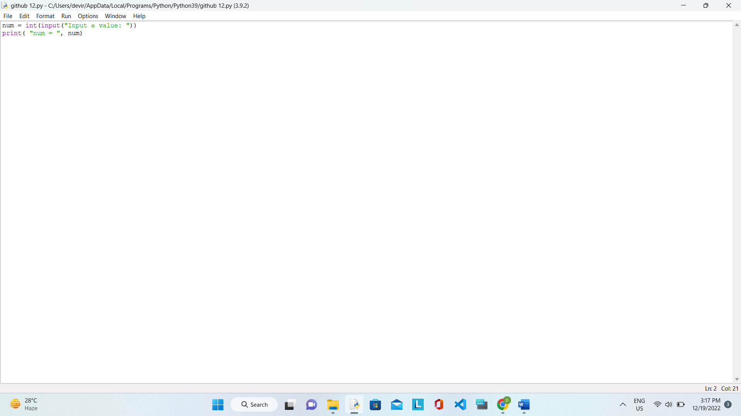

OUTPUT: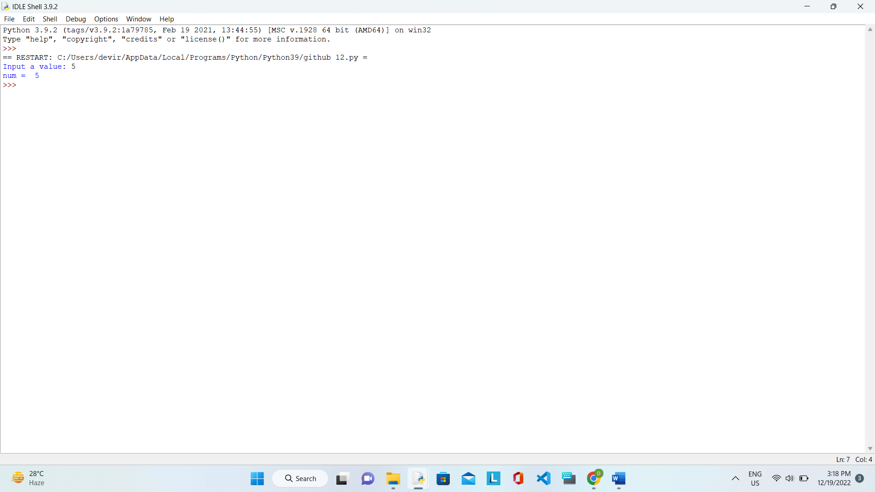

## 13.  to test multiple variables against a value in Python:

OUTPUT: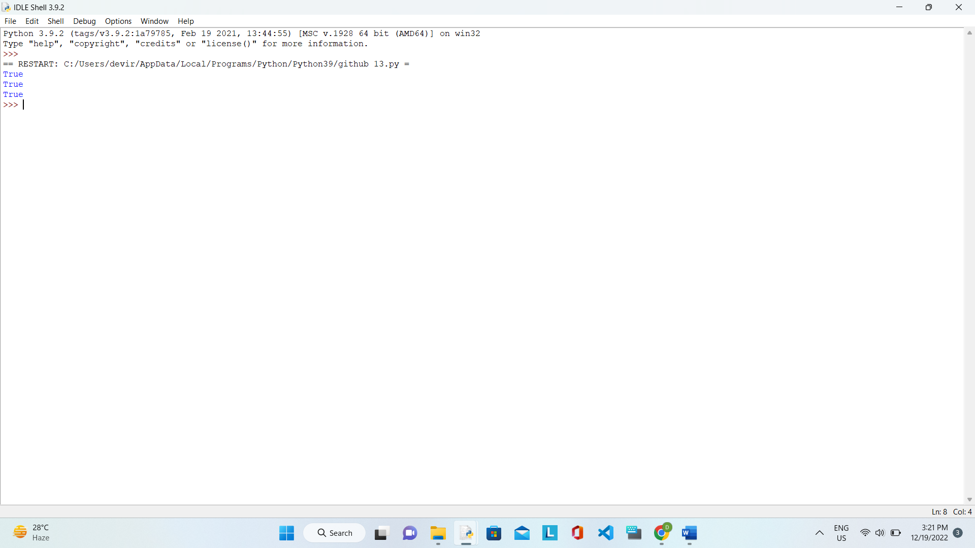

14. Program to define an integer value and print it:

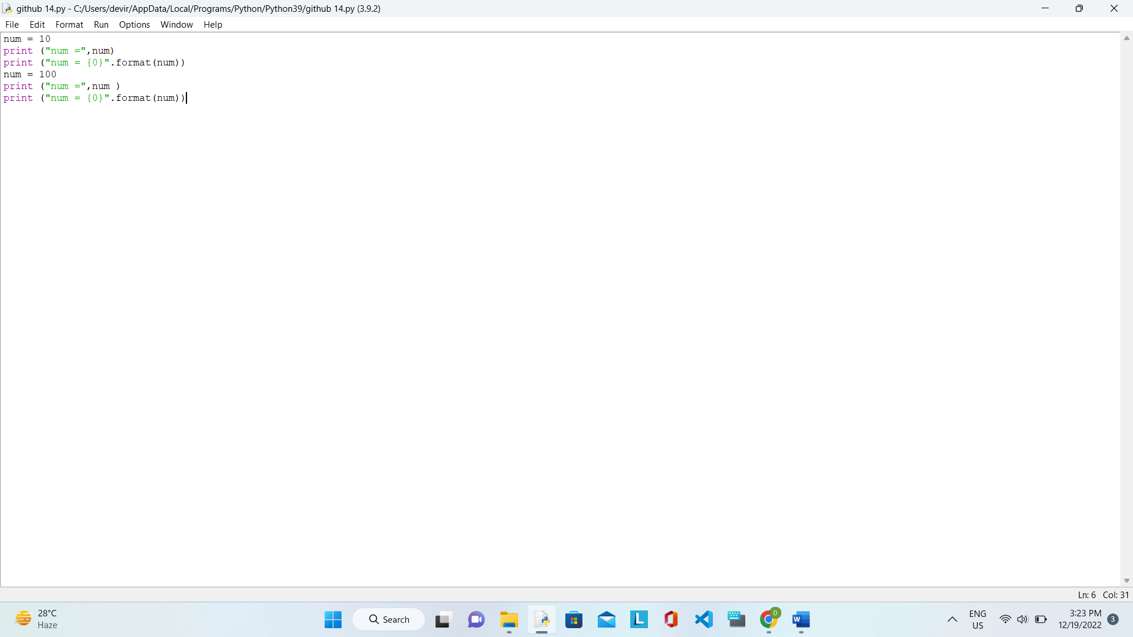

OUTPUT: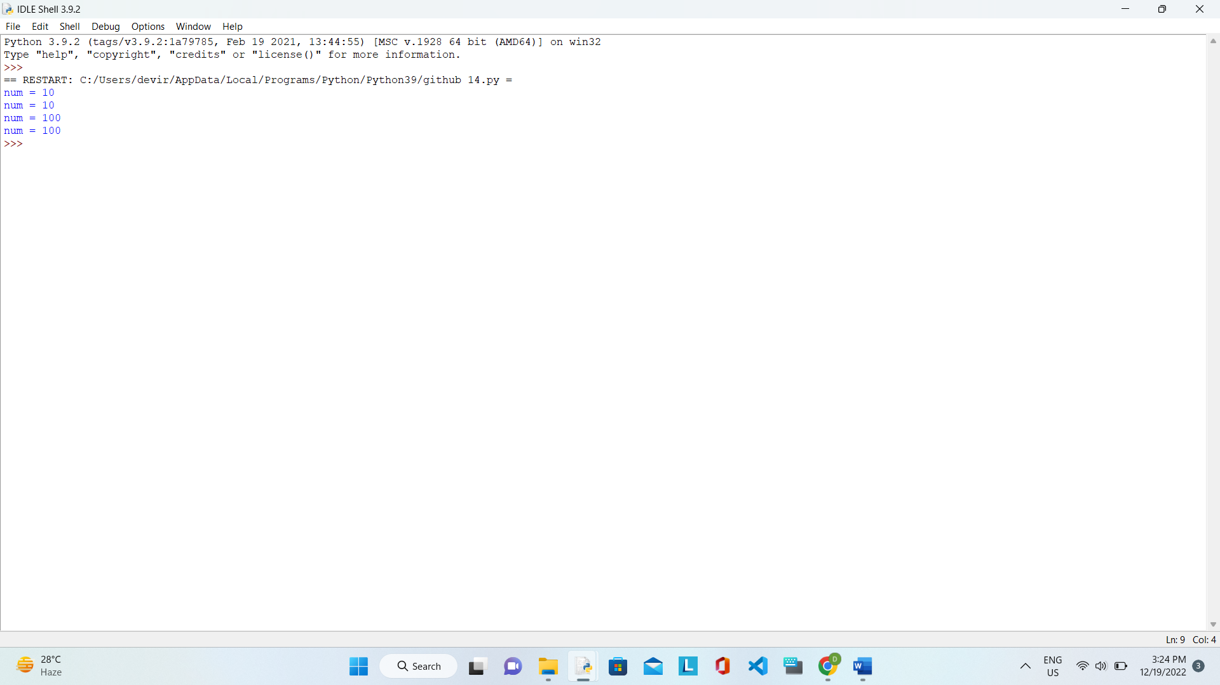

15. Program to define an integer value and print it:

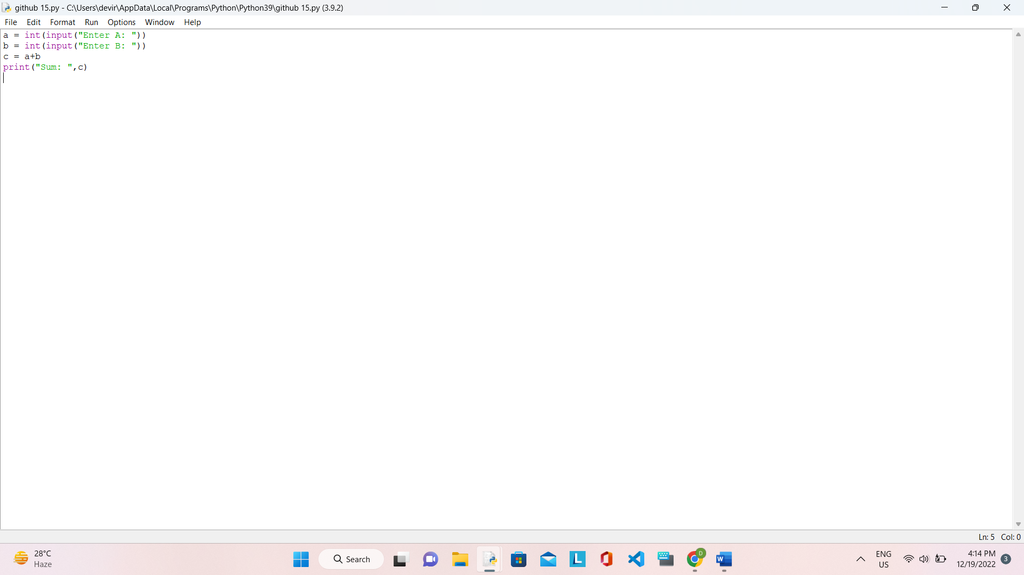

OUTPUT:

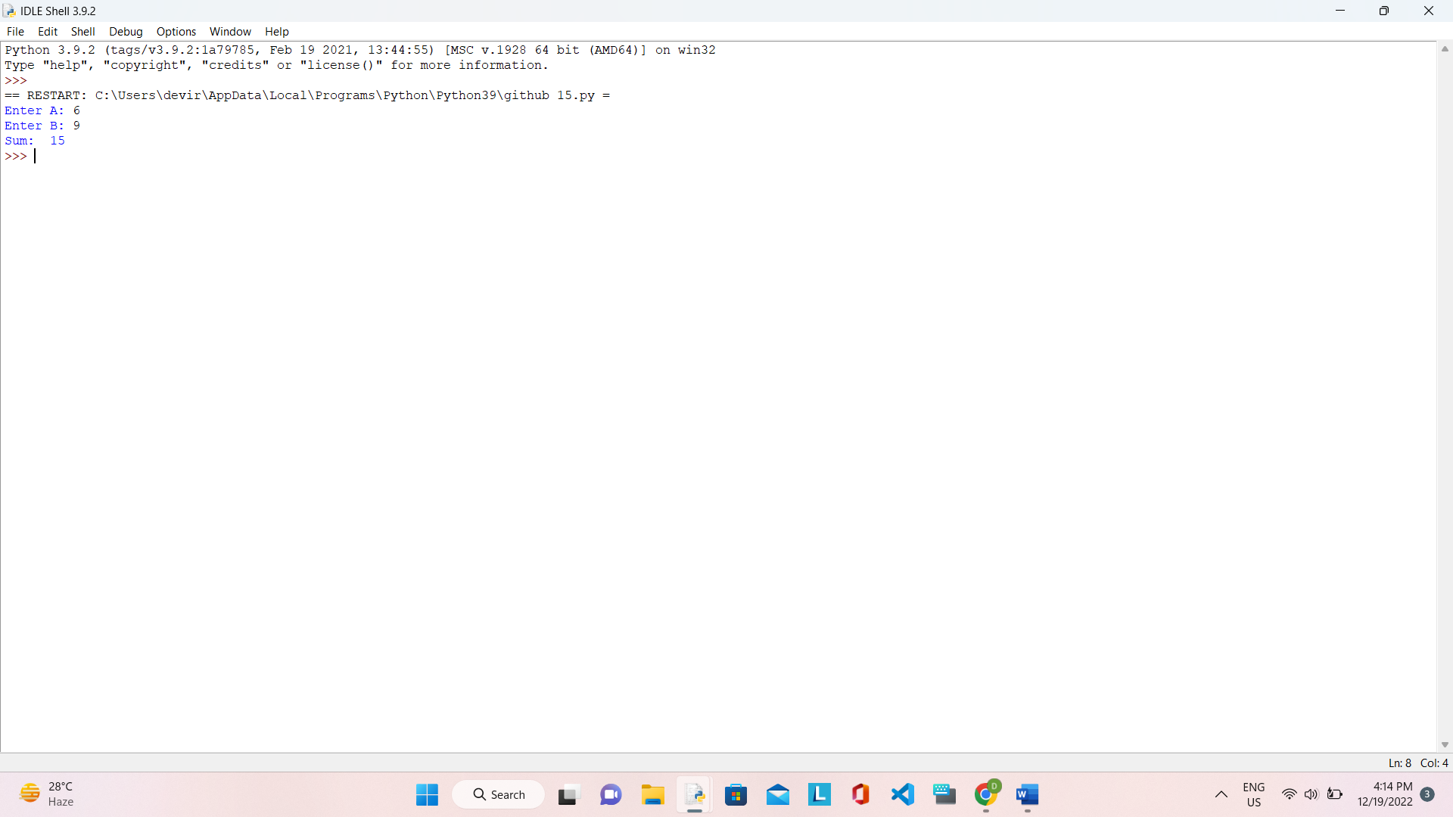

16. SUM OF TWO NUMBERS: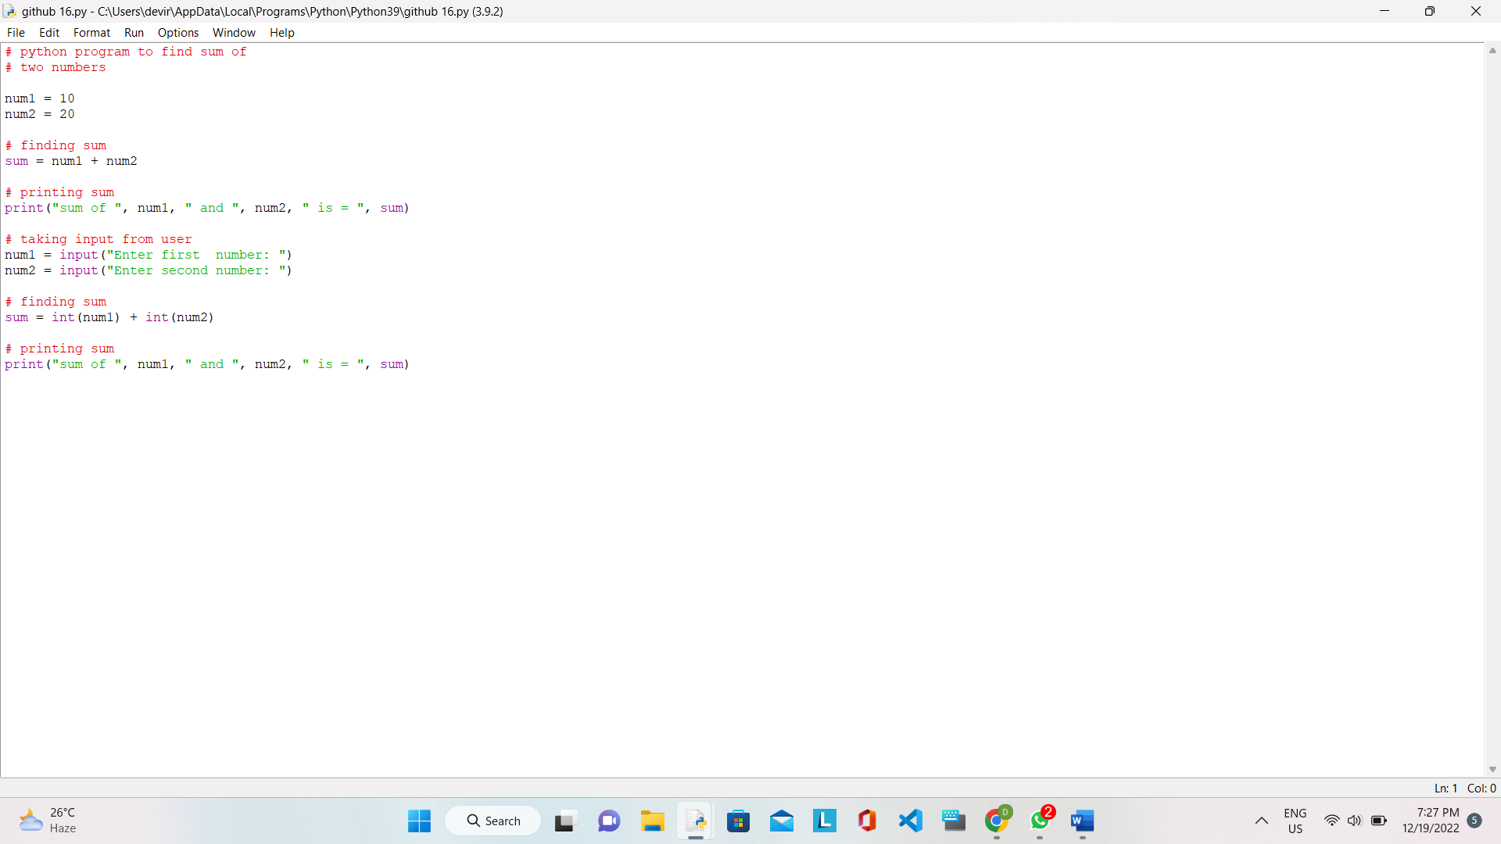

OUTPUT: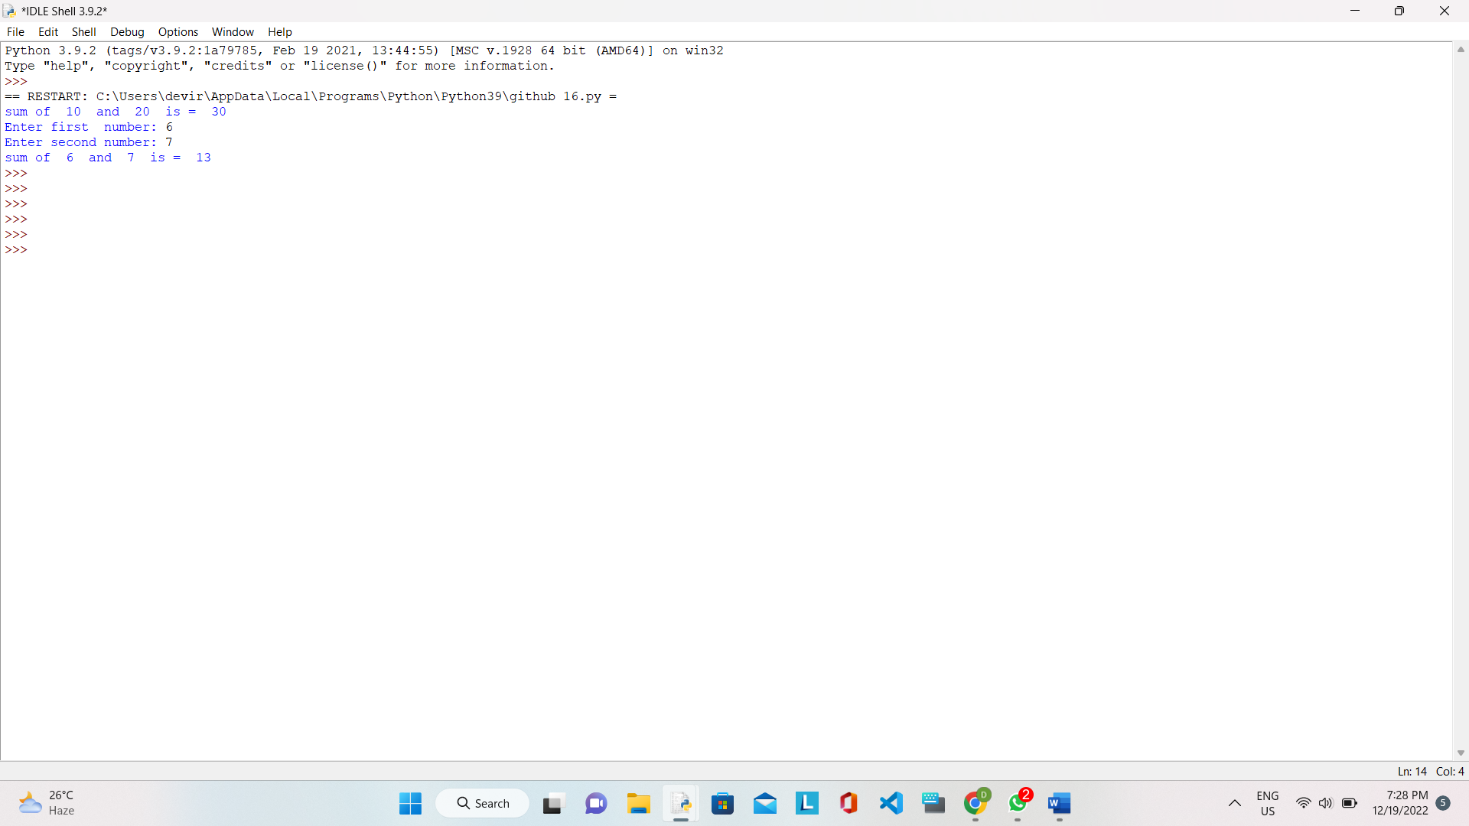

17. ADDITION OF TWO NUMBERS: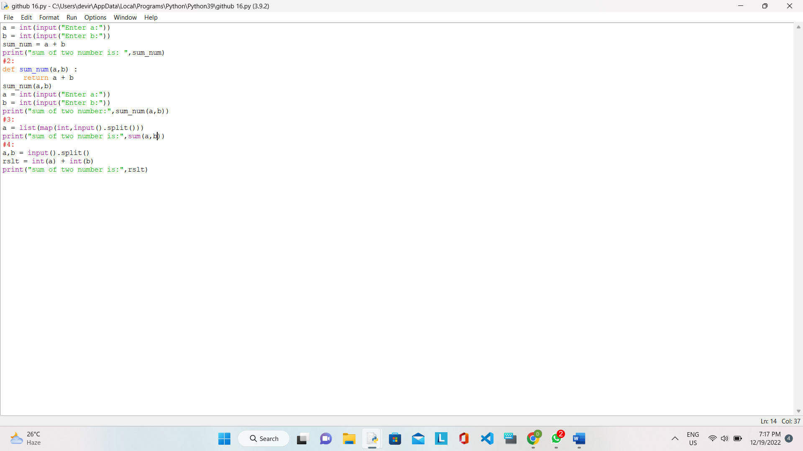

OUTPUT: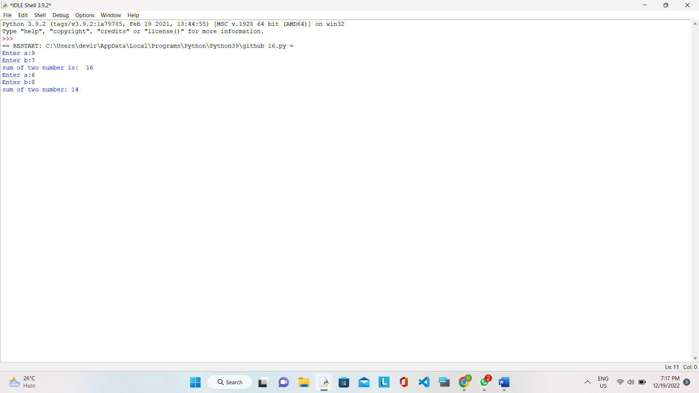

18.ARITHMETIC OPERATORS: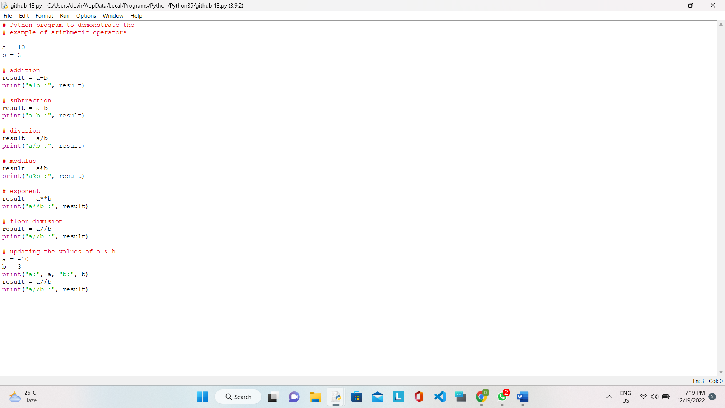

OUTPUT: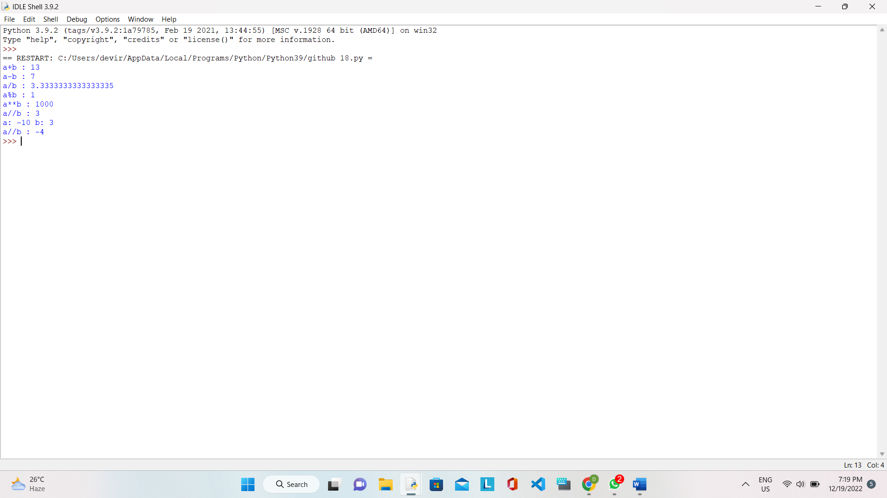

19. PRINT ASCII VALUE OF A NUMBER: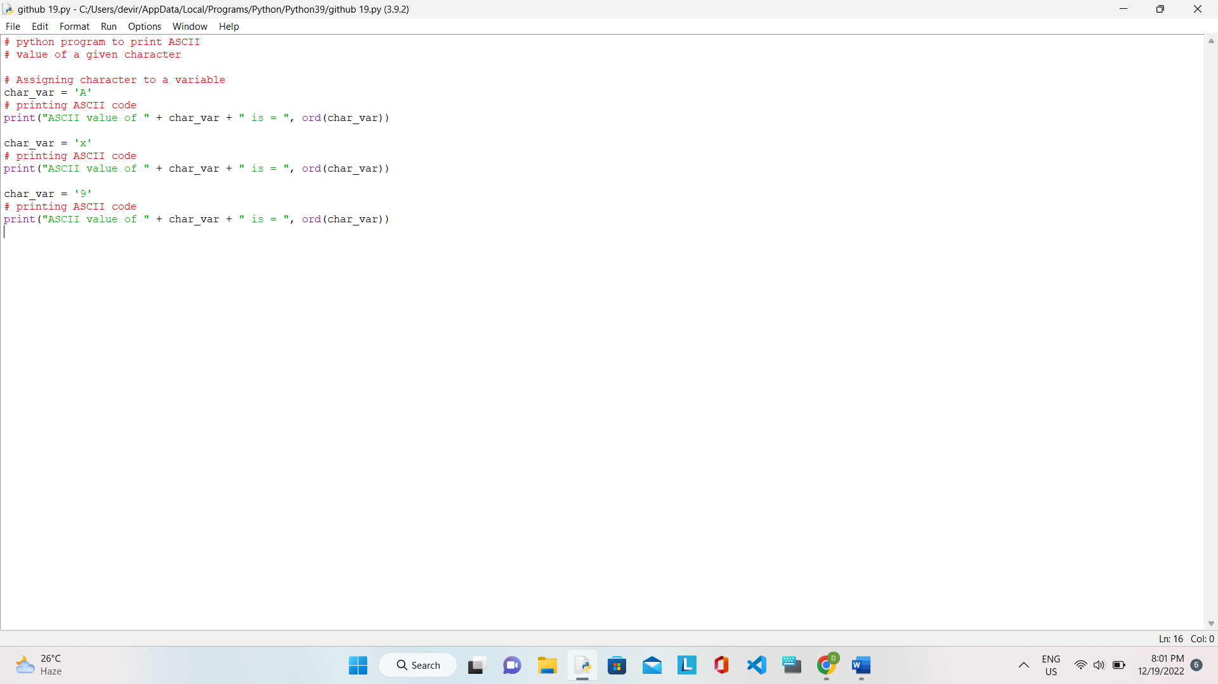

OUTPUT: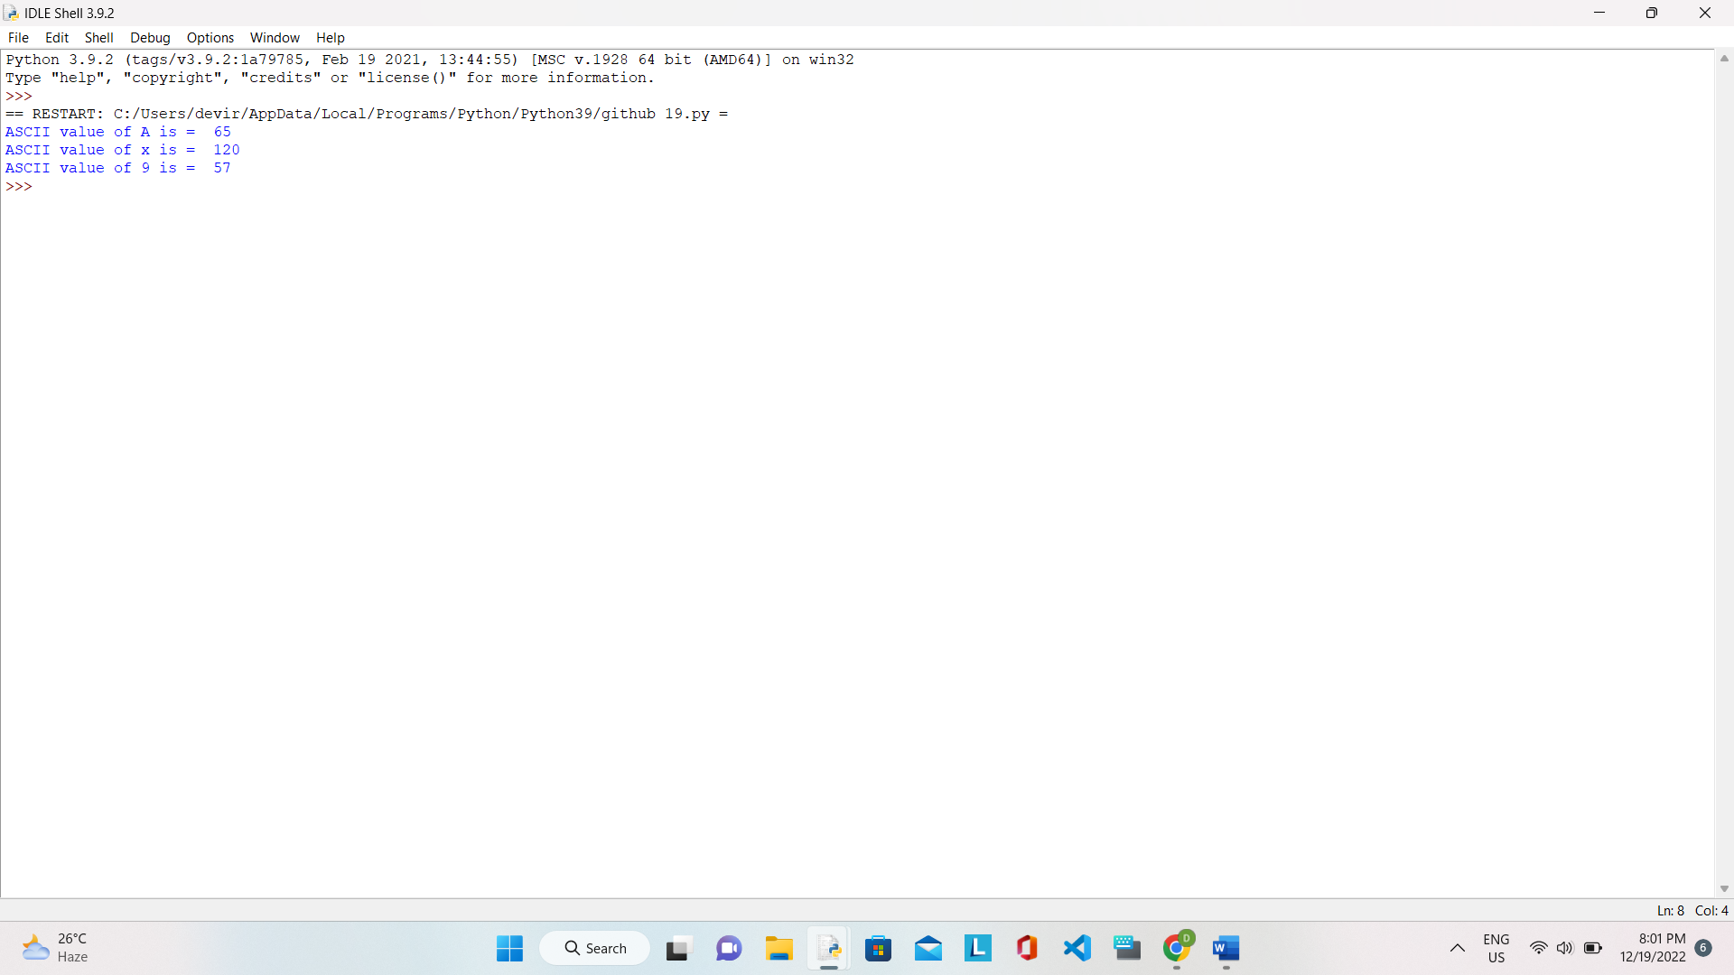

20. SIMPLE INTEREST: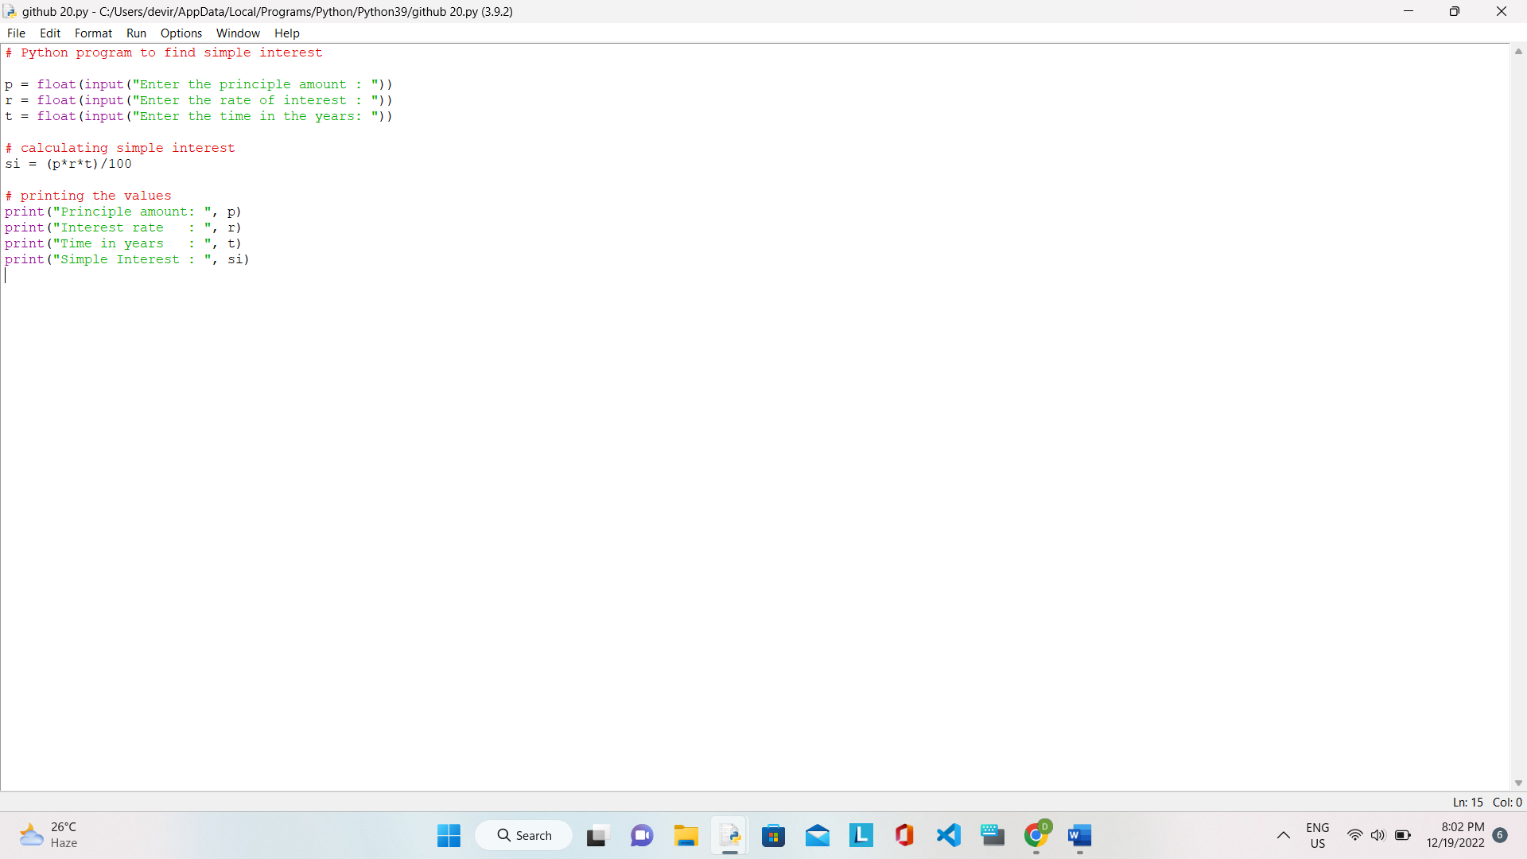

OUTPUT: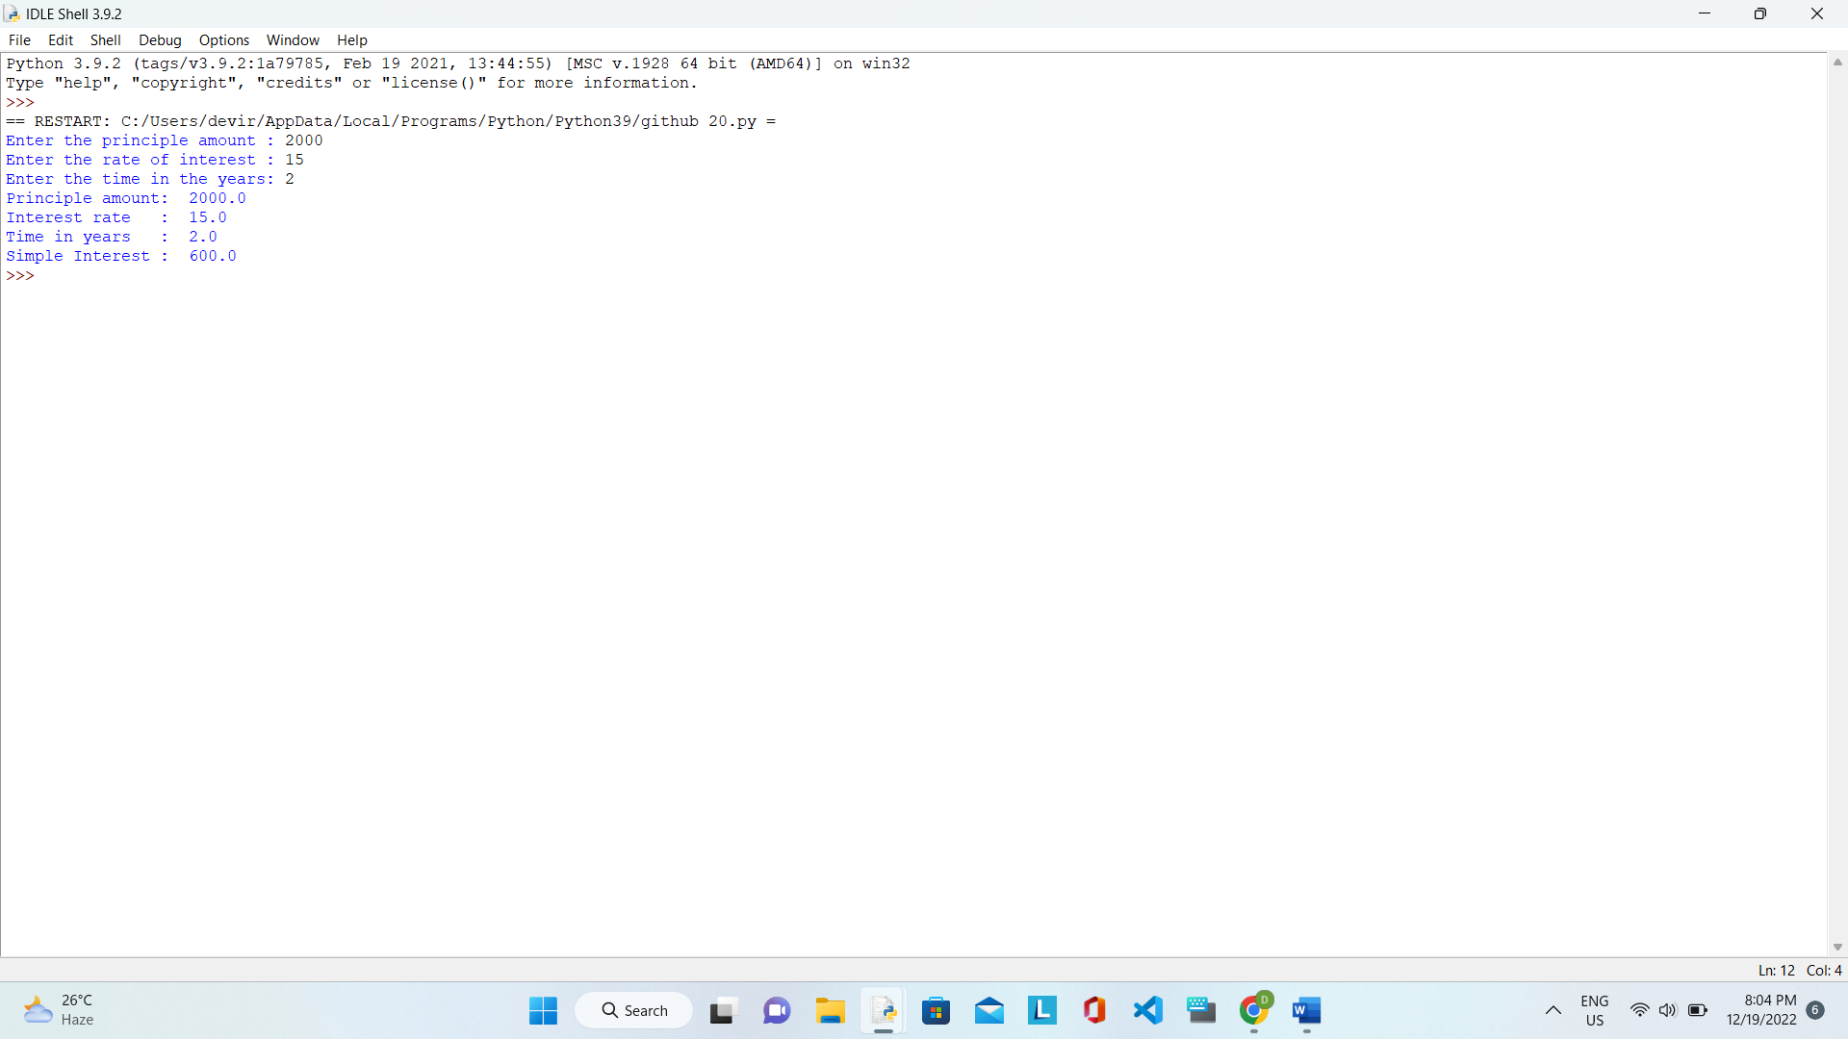

21. COMPOUND INTEREST: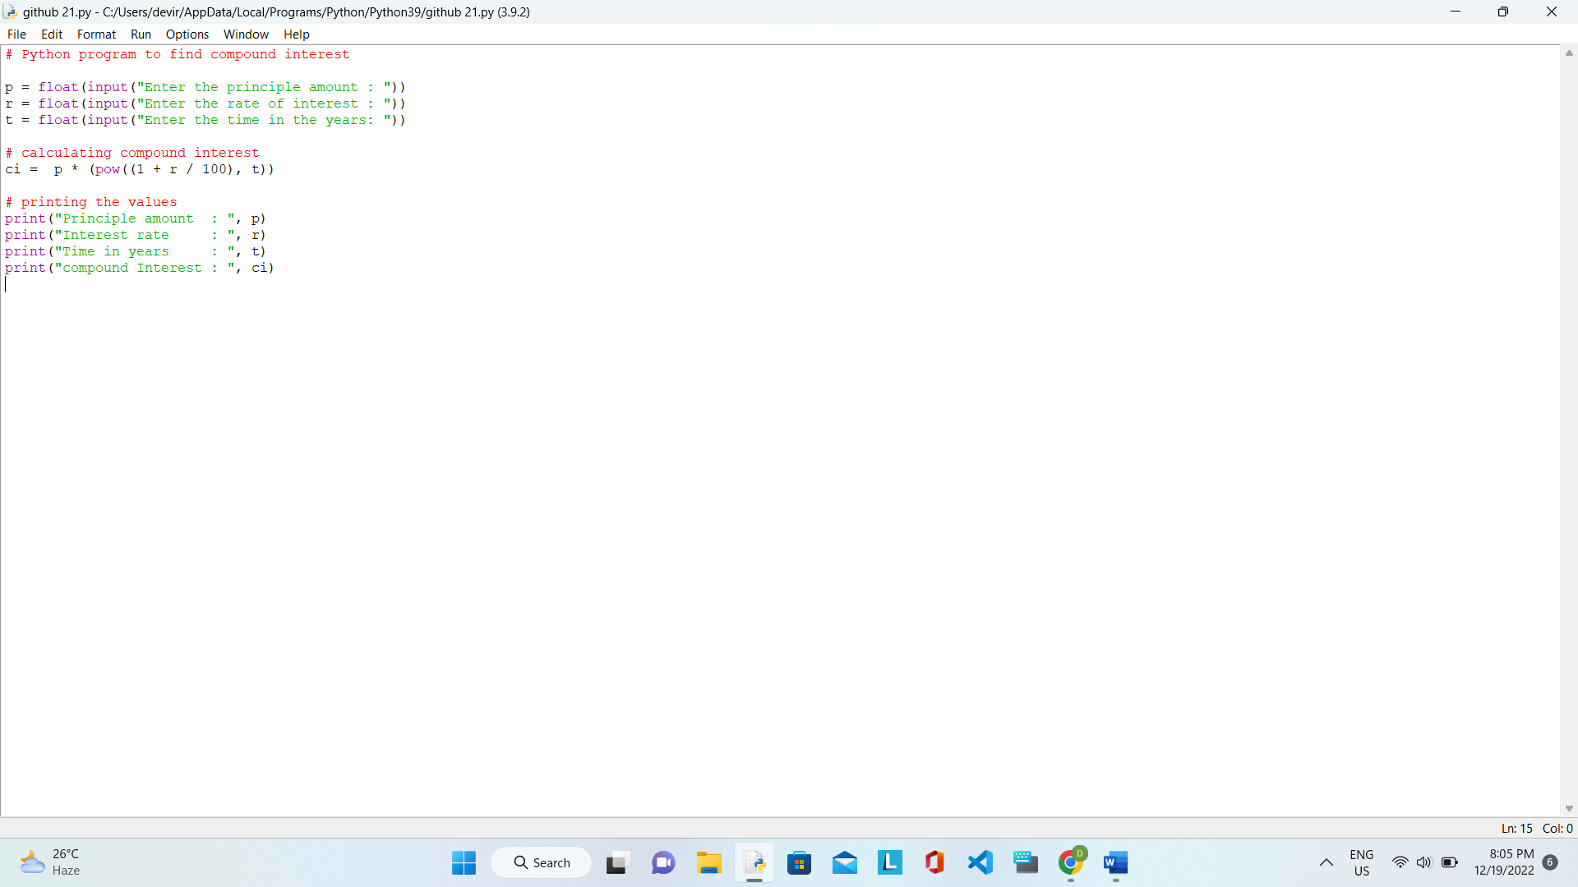

OUTPUT: